# CHAPTER 1 INTRODUCTION TO THE STUDY

# Background of the Study and Theoretical Framework

In prior years, the thesis monitoring process at West Visayas State University - College of Information and Communications Technology was performed manually. Students are required to submit hard copies for manuscript review and must submit their work in person, which is both expensive and time-consuming. Schedules are still posted on Facebook, a social media application, and Google Drive is used for the submission of soft copies, resulting in the dispersion of data. In prior years, the College of Information Communication and Technology at West Visayas State University (WVSU-CICT) handled theses manually. Formally, the thesis procedure begins with the formation of the thesis committee and the approval of the thesis proposal. The invitation to the Thesis Advisor then follows the 20% and 50% Thesis Progress Presentations and the Final Thesis Presentation. The students, the thesis adviser, the thesis committee, the thesis editors, and the undergraduate research coordinator spend inefficient amounts of time on this labor-intensive, paper-based procedure. In addition, students are required to submit physical copies of their manuscripts and must submit their work in person, which is both costly and time-consuming.

Before a student can graduate from the College of Information and Technology at West Visayas State University (WVSU CICT), they must complete a thesis. Students and faculty at the WVSU CICT collaborate annually on the thesis. Due to the accumulation of student work in their respective projects, it is becoming progressively more difficult to maintain and preserve research materials. In the midst of a pandemic, it is particularly difficult to access and acquire completed historical research without visiting a library. It can be difficult for thesis advisers to monitor the progress of their students' theses when they have insufficient contact with the students they are advising. The WVSU College of Information and Communications Technology (CICT) intends to design and implement a thesis administration system that will facilitate the storage, organization, and retrieval of thesis documents. The proposed study enables for the efficient administration of the research and thesis documents created by former and future CICT students at West Visayas State University. The CICT's research initiatives are significantly more innovative and forward-thinking than those of other research departments. In addition to managing the various documents associated with the thesis, the system is designed to encompass the entire process of composing the thesis. This system's primary function is to provide CICT with a web-based thesis monitoring and archiving system.

## Theoretical Framework

Locke and Latham's (2002) theory of motivation pertaining to goal-setting highlights the significant role of goals in relation to performance. Research suggests that individuals are more likely to reach their maximum potential when they are presented with explicit and challenging goals that are utilized to evaluate their performance and connected to feedback on outcomes. Additionally, when these goals foster commitment and acceptance, individuals are more likely to achieve their desired outcomes. The act of monitoring the progress of a goal has been found to enhance one's focus and attentiveness towards the task at hand. This, in turn, facilitates the continuous allocation of resources towards the attainment of the goal while minimizing disruptions caused by non-essential activities. According to Lunenburg's (2011) study, the aforementioned factors collectively contribute to optimal performance, thereby corroborating the theory and lending credence to its validity.

This research is based on the theoretical framework of task-technology fit. The present theory posits that in order for a technological innovation to yield a favorable effect on performance, it must initially align with the specific task it is intended to facilitate. According to Goodhue et al. (2006), the performance of an individual is directly and positively influenced by the level of compatibility between the participant and the environment. According to a study conducted by Omotayo and Haliru (2020), recent research on digital libraries has revealed that students are utilizing digital libraries at their educational institutions due to their perceived usefulness of the contents contained within them. The present findings provide support for the Technology Acceptance Model (TAM) by indicating that individuals opt to adopt and utilize novel technology when it is advantageous for them to do so. The survey results indicate that digital libraries are extensively utilized by students across diverse educational institutions. The implementation of a document management system (DMS) within an organization can facilitate the accessibility, management, and sharing of information among its users. According to Kao and Liu (2013), the platform offers essential features such as document editing, sharing, and synchronization, while also accommodating a diverse range of client devices.

# Objectives of the Study

This research generally aims to develop a web-based thesis progress monitoring and archiving management system for WVSU-CICT.

Specifically, it aims to:

1. Develop a system that is able to assign student groups, generate presentation schedules, and enable the submission of documents and approval of concepts.

2. To develop a system with list of thesis advisers for selection, invitation acceptance or rejection, and adviser notification

3. To create a system that will track the completion of progress presentations and the editing of thesis manuscripts.

4. To create a system that will serve as a repository for CICT students' past and upcoming theses documents, as well as classify documents based on their research area.

5. To evaluate the quality of the system using ISO 25010.

# Significance of the Study

The following entities will benefit greatly from the study's findings:

*CICT.* This system will facilitate the general monitoring and archiving of student theses by the college.

*Faculty and personnel*. The proposed system has the potential to assist the faculty and staff of the College of Information and Communications Technology (CICT) in preserving and organizing their research articles, both past and future. The data may serve the purpose of guiding students towards research topics that would help maintain equilibrium in the number of theses across various research areas, as well as monitoring the volume of theses in a given research domain*.*

*Students.* The enhanced accessibility of past research papers facilitated by the system will enable students to utilize them as references or pertinent reading materials for their own research papers. The system has the potential to aid individuals in the process of revising their manuscripts. This is due to its capacity to alert users when their thesis adviser has made modifications to their uploaded manuscripts, thereby furnishing them with comments and recommendations.

*Thesis Advisers.* Additionally, the system will aid thesis advisors in tracking and monitoring the theses assigned to their students. Even if they are out of town, they are able to provide immediate feedback and suggestions when students upload their papers.

# Definition of Terms

For better understanding, the following terms were defined conceptually and operationally:

*Classification* -- the process of identifying and grouping objects or ideas into predetermined categories (Techopedia, 2021).

In this study, classification is the act of classifying the thesis documents to determine their field and area of research.

*Data visualization --* Data visualization is the common term that is used to describe presenting data in a pictorial or graphical format (Umadevi et al., 2020).

In this study, data visualization was used to visualize the number and amount of data in every research field, and a bar graph was employed to achieve this.

*Document management - - i*s concerned with the distribution, storage, and retrieval of documents (Wiggins, 2020).

In this study, document management is the way of organizing and storing the uploaded thesis in the system.

*Progress Monitoring --*A form of assessment in which student learning is evaluated on a regular basis to provide useful feedback about performance to both students and teachers (Brown, 2021).

In this study, progress monitoring is used to track and monitor the progress of the research papers of the students to see if they are ready for presentation. These follow the 20%, 50%, and final presentations of the thesis.

*Scheduling* -- is a technique for allocating important computer resources, such as processor time, bandwidth, and memory, to the numerous processes, threads, data flows, and applications that require them (Techopedia, 2017).

In this study, scheduling will be applied to the presentation schedule of thesis progress, including the concept presentation, 20%, 50%, and final defense.

*Thesis Archiving*-- A process by which inactive information, in any format, is securely stored for long periods of time (Securedatamgt, 2015).

In this study, thesis archiving is the process of storing all the past and successful thesis documents of WVSU CICT as a repository, in which documents are accessible by CICT students.

# Delimitation of the Study

The primary objective of this thesis is to develop a comprehensive system that can effectively allocate group presentation schedules for students, facilitate the submission and approval of documents and concepts, generate a list of available thesis advisers for students to choose from, monitor the progress of thesis manuscripts, and function as a repository for the past and future theses of CICT students. Additionally, the system will be designed to categorize documents based on their respective research areas.

# CHAPTER 2 REVIEW OF RELATED LITERATURE

Review of Existing and Related Studies

*Thesis Management System*

According to Alano et al. (2018), their Thesis management System involves the administration of thesis documents created by former Polytechnic University of the Philippines students who majored in information technology and computer science. Advocates suggest the development of an online platform for managing theses, which would enable numerous students to access it remotely, without the need to physically visit the research facility. The system monitors specific research materials accessed by a student and generates a report of the top five most preferred and top five most frequently accessed thesis documents. It also served as a repository for research, just like the proposed system, but the main difference between the two is that the proposed system gave students the opportunity to submit their final group and invite the professor of their choice to serve as their thesis adviser, and it also provided the opportunity for panels to evaluate the paper and offer comments.

The study titled "Collaborate IT: A CCS IT Thesis Portal with Electronic Document Management System" has employed the Rapid Application Development (RAD) methodology as its chosen approach. The portal comprises nine distinct modules, namely preparation, request, consultation, defense scheduling, evaluation results, revisions, document management, report generation, and consultation and announcements. This system bears resemblance to the proposed system. The only difference is that the proposed system will only allow viewing of research and it includes a progress monitoring system that tracks students' thesis progress from concept paper to 20%, 50%, and finally to completion.

The Data Management System for Thesis Monitoring at STMIK IBBI Using a B-Model Study states that it employed a B-Model, which was an improvement on the waterfall method in that it emphasized the maintenance phase.The academic section can monitor the progress of a student's thesis completion through the system designed, and lecturers can also carry out the guidance process without regard for time or space. The proposed system did not use BModel, but it is similar in that it also tracks the completion of a student's thesis.

The authors of the study Web-Based archival System designed and implemented an archival system to alleviate the burden of physical copies and the difficulty of maintaining a paper inventory and locating a particular document. The system is simple, straightforward, and web-based. It was primarily based on the XAMPP application and the PHP programming language, both of which are comparable to the proposed system but differ in that the proposed system is more than an archiving system because it includes the entire thesis process, from group submission to manuscript archiving.

Similarly, to the proposed system, the system described in the study "ELECTRONIC DOCUMENT MANAGEMENT SYSTEM FOR St. Mary's University" can prevent document loss or destruction caused by disasters such as fire, flooding, animals such as rodents, or human error. The main difference between the two systems is that, unlike the proposed system, this one is just for document management.

The use of a web-based data archive management system is the subject of this study. This study's objective is to replace the manual file and paper sorting, storing, searching, retrieving, and moving that is time-consuming, tiresome, and inefficient, similar to the suggested system. The suggested solution differs in that it covers the entire thesis process rather than just archiving. Since XAMPP was utilized by both platforms, the web server could be installed on either OS.

Information System Design Thesis Monitoring research seeks not only to automate the previously manual process of thesis submission, but also to monitor each student's progress towards completing his or her own thesis*.* Thesis Monitoring Information System offers a solution for the problem of submitting a thesis proposal online. Additionally, it offers targeted planning and information to students concerning the length of time required for each activity.  In addition, this system makes it easy for lecturers to accept student thesis proposals on a consistent basis online, monitor the progress of students working on theses, and assess student reports of activities related to theses.

According to the development of the Shodhganga Repository for Electronic Theses and Dissertations in Tamil Nadu: A Study, thesis and dissertation collections are essential components of the information resources available at any given university. Some of the universities in Tamil Nadu are in the process of establishing repositories for their student theses and dissertations. Educational institutions should store the results of their study in a location where members of the institution can easily access it for the purpose of conducting reference checks. Repositories of electronic theses and dissertations are rapidly becoming important sources of information on a wide variety of topics. The printed theses and dissertations that were handed in by students to a particular university became the property of that university. Other people were not able to easily access or see the theses and dissertations that were handed in. ETD repositories, on the other hand, are helping to solve this issue by making institutional information accessible online and, as a result, boosting both its visibility and its utilization.

The Design and Implementation of an Online Management System for Undergraduate Theses (Project) is based on an online management system for undergraduate theses that has significant practical value for the improvement of instructional management and quality. The creation of the system is carried out with the assistance of ASP.Net and SQL Server, and it accommodates four distinct user groups, namely system administrators, teachers, students, and auditors. In the article, the duties of the four different types of users, workflow, and design ideas are discussed, as well as various design strategies that can be used to increase the system's level of security. The technique has been successfully implemented in a number of Huaibei Normal University schools after receiving widespread publicity and promotion there.

The Progress Monitoring System for Student Final Year Project (PSM) is computer software that assists University Malaysia Pahang (UMP) student contacts under Faculty System Computer and Software Engineering (FSKKP) in gaining better control of their project planning and implementation by keeping students connected with the supervisor. Offer mail gateway services to someone who is unfamiliar with the project management system. Similarly, to the suggested method, the supervisor can communicate with students at any time and from any location; there is no requirement for students to move and physically view the supervisor. Unfortunately, some pages contain far too much information, and there are few guidelines. There are too many options to pick from, and people may become disoriented. The primary difference between the two systems is that this one is just for progress monitoring.

# 

# 

# CHAPTER 3 RESEARCH DESIGN AND METHODOLOGY

# Description of the Proposed Study

This study in general targets the storing of complete and final thesis by CICT students. The volume of research done by CICT students is accumulating annually and safekeeping them. The web-based thesis progress monitoring and archiving system will employ a web framework. This system will not only ensure the safekeeping of the students' research but will also provide a platform for monitoring the progress of their thesis. With the use of a web framework, the system will be accessible to students and faculty members, making it easier to manage and organize the stored theses. The web-based system will also provide a platform for collaboration among students, allowing them to share ideas and resources with one another. With the implementation of this system, the CICT department can ensure that the hard work of its students is properly documented and preserved for future reference.

Methods and Proposed Enhancements

The proposed system improvements encompass several key features, including the ability to assign student groups, generate presentation schedules, and facilitate the submission and approval of documents and concepts. Additionally, the system would include a comprehensive list of thesis advisers for selection, invitation acceptance or rejection, and adviser notification. Progress presentations and thesis manuscript editing would be closely monitored, and documents would be classified based on their respective research areas. Moreover, the proposed system would incorporate a feedback mechanism for both students and advisers to provide comments and suggestions on the progress of the thesis. This feature would enable students to receive constructive criticism and continuously improve their work. Furthermore, the proposed system would have a user-friendly interface that is easy to navigate, making it accessible to all users regardless of their technical expertise. In summary, the proposed system improvements aim to improve the thesis process by providing features such as group assignments, presentation scheduling, and document submission and approval. The system would also include a comprehensive list of thesis advisers, progress presentation monitoring, manuscript editing monitoring, and document classification based on research areas. These improvements would streamline the process and provide better support for both students and advisers, enabling students to focus on their research and produce high-quality work that contributes to their respective fields of study, and ensuring that students stay on track and receive timely feedback, while also facilitating collaboration.

# Components and Design

*System Architecture*

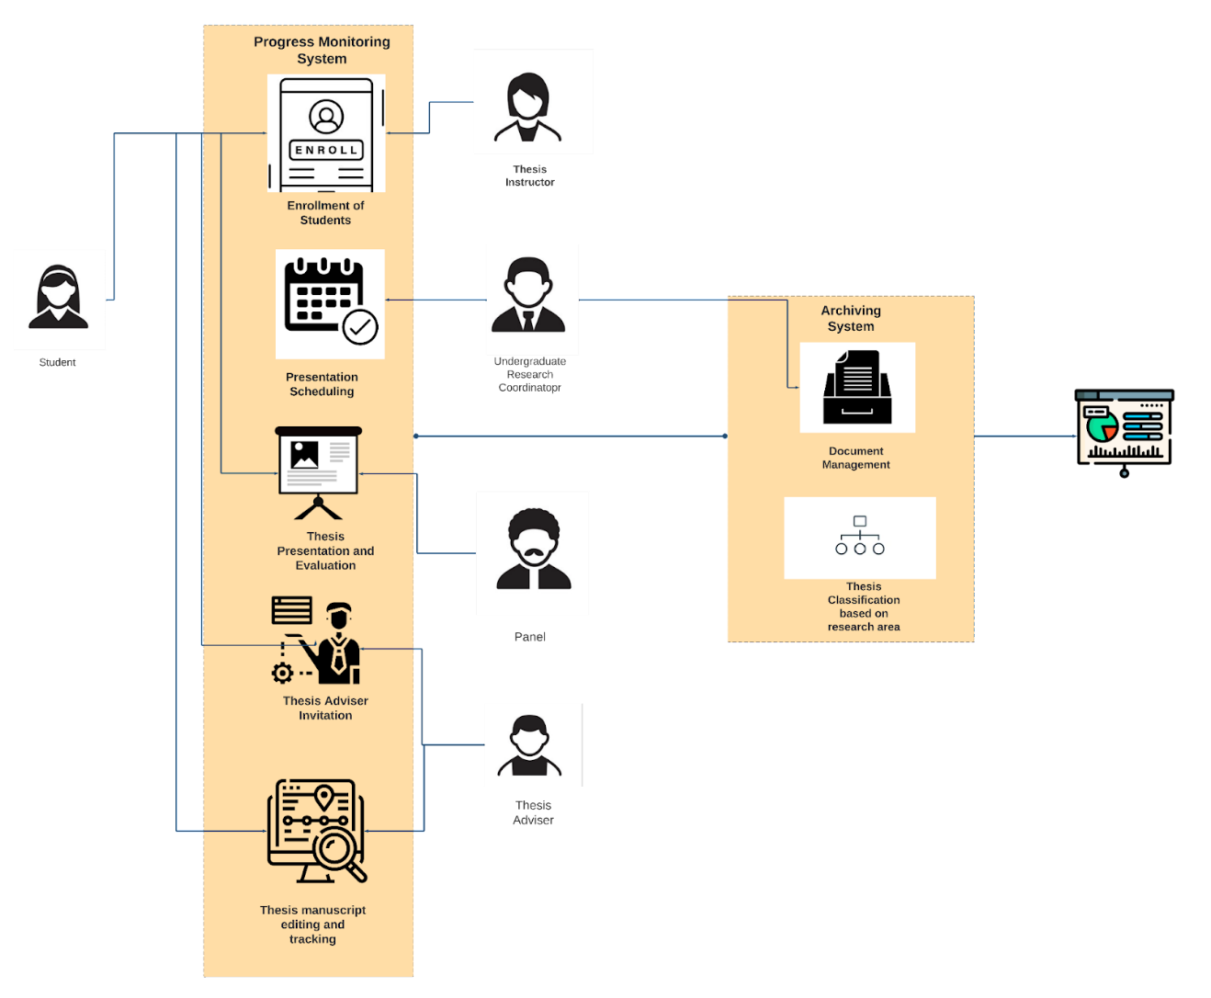

**Figure 1.** System Architecture

The diagram depicted in Figure 1 provides an overview of the system. The initiation of the process occurs when a student enrolls in the web application through a web browser that is connected to the internet, either through wifi or data services. Upon registration, students can access the web application and navigate to the user interfaces, which enable them to send invitations to their thesis advisers and monitor the progress of their thesis manuscript. Subsequently, the coordinator responsible for overseeing undergraduate research endeavors proceeds to generate a presentation schedule that will be displayed on the dashboards of both the participating students and panelists. The individual responsible for overseeing research activities can additionally upload completed theses authored by graduates of the College of Information and Communications Technology (CICT) and categorize them according to distinct research domains. The research documents of a confidential nature will be presented in a visual format on the dashboard, exhibiting the degree of saturation within each respective field of research.

*Database Design*

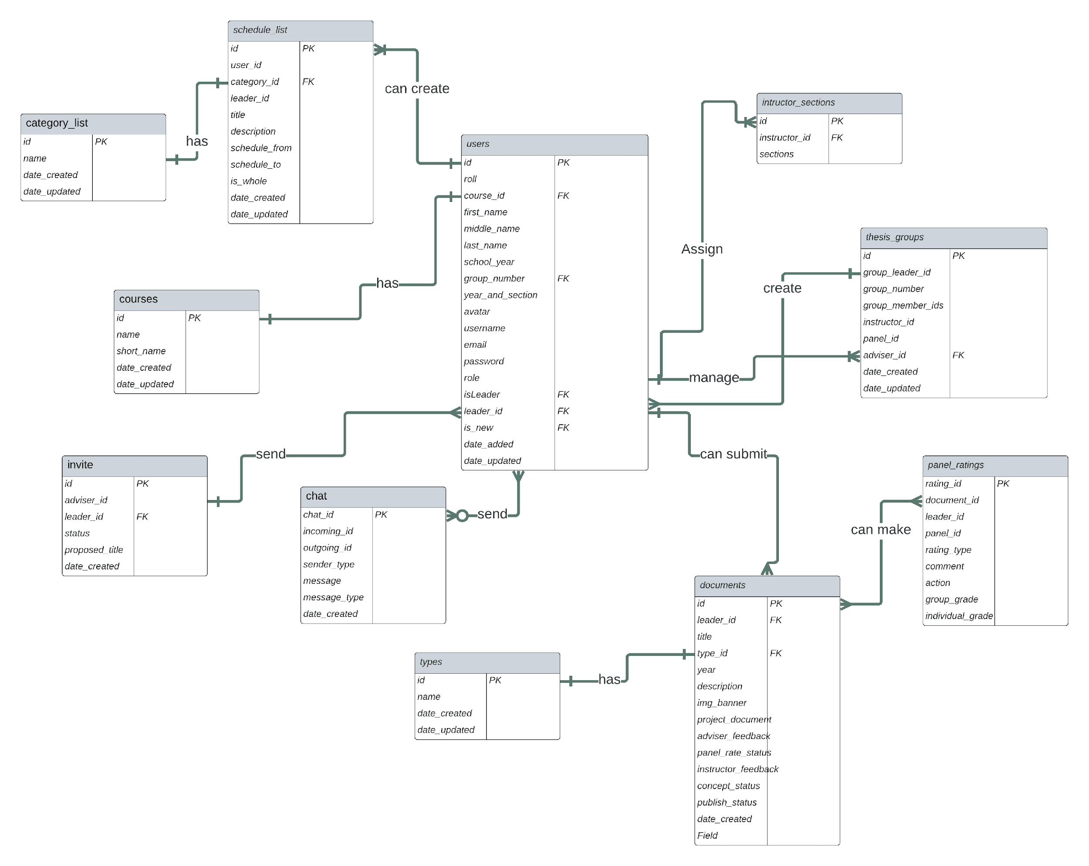

**Figure 2.** Database Design

The ERD, or entity relationship diagram, of the web-based system is depicted in Figure 2, which illustrates the database design. Consequently, diverse roles can be allocated to users, encompassing but not limited to students, panels, thesis advisers, thesis instructors, and thesis coordinators. Commencing with the user's statement, it is noted that the thesis coordinator possesses the ability to allocate instructor sections and generate several schedules, each of which is classified under a distinct category. The individual has presented the entity relationship diagram (ERD) of the web-based system, which depicts the database design. Consequently, diverse roles can be allocated to users, encompassing but not limited to students, panels, thesis advisers, thesis instructors, and thesis coordinators. Commencing with the user's statement, it is noted that the individual responsible for overseeing the thesis program has the authority to allocate instructor sections and generate various schedules, each of which may pertain to a distinct category. The thesis instructor possesses the capability to generate numerous groups, designate a leader for each group, and transmit a variable number of messages. Panels possess the capacity to evaluate a substantial quantity of documents that share a common type. The individual serving as a thesis adviser has the potential to receive a significant quantity of invitations, correspondingly send an indeterminate number of messages, and oversee the management of one or multiple thesis groups. Ultimately, the user is afforded the choice to transmit an indeterminate number of messages, extend invitations to one or more thesis advisors, and present a singular document for submission.

Procedural and Object-Oriented Design

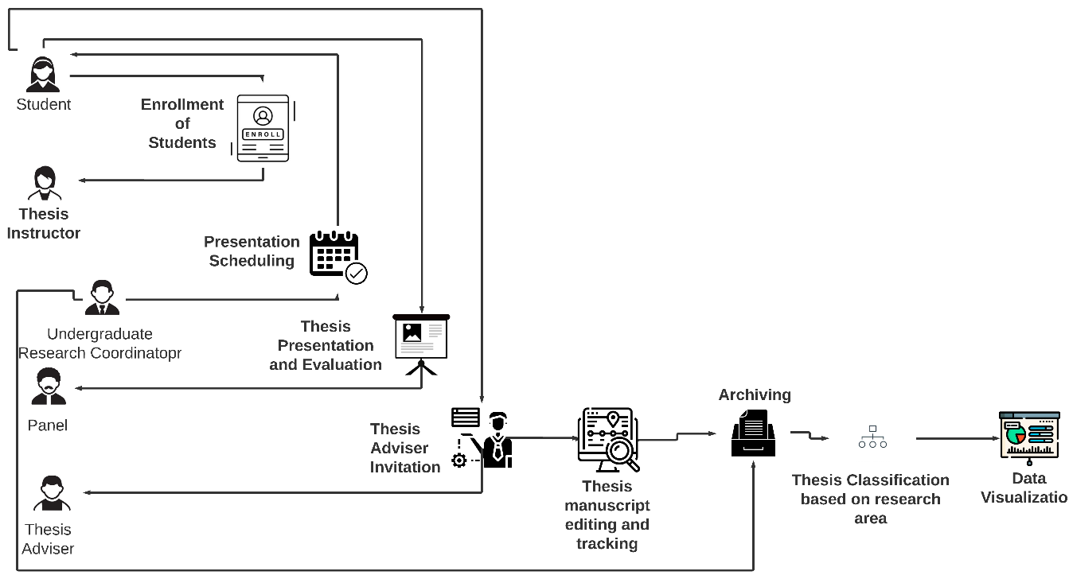

**Figure 3.**General Overview of the System

The diagram presented in Figure 3 provides a comprehensive depiction of the system's overall process. The initiation of the process commences with the enrollment of a student into the web-based application through a web browser that is linked to the internet, facilitated by either wireless fidelity or data services. Upon registration, students can access the web-based platform and navigate to the designated user interfaces, which enable them to dispatch invitations to their thesis advisers and monitor the progress of their thesis manuscript. Subsequently, the coordinator responsible for overseeing undergraduate research endeavors proceeds to generate a presentation schedule, which will be displayed on the dashboards of both the students and panelists. The individual in charge of overseeing research activities can additionally upload completed theses authored by graduates of the College of Information and Communications Technology (CICT) and categorize them based on various research field classifications. The research documents that are classified will be presented on the dashboard, exhibiting the degree of saturation in each respective research field.

# Procedural Design

Using the swim lane diagram that Cabacas et al. (2022) provided, the following figures detail the proposed system's procedural design:

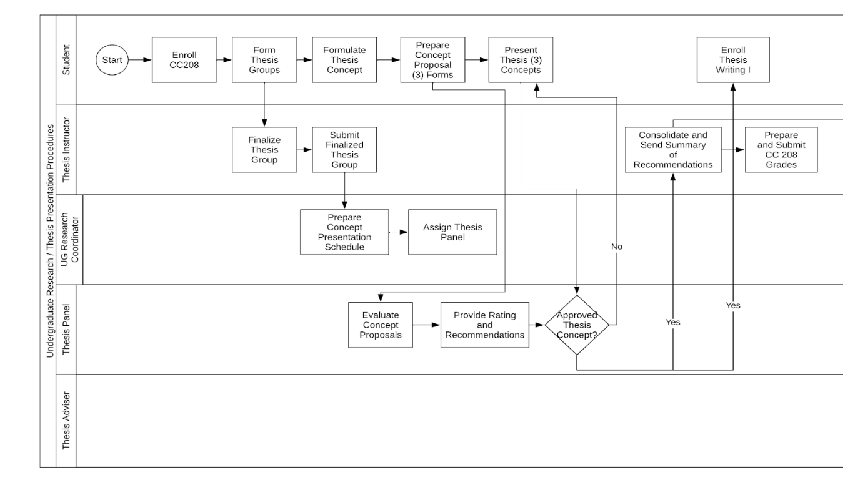

**Figure 4**. Procedural Design for the Preliminary stage of Thesis Process by R. Cabacas, 2022, Manual of Operations for CICT Undergraduate Research Unpublished

The enrollment procedure for students is illustrated in Figure 4. The initial step of the process involves the initiation of enrollment for CC208, wherein the student is required to furnish a sign-up form. The form solicits the student's pertinent details, such as their student number, first name, middle name, last name, school year, year and section, group number, email address, and password. Upon completion of the registration process, the student will be directed to their personal dashboard, where they may await assignment to a thesis instructor's group.

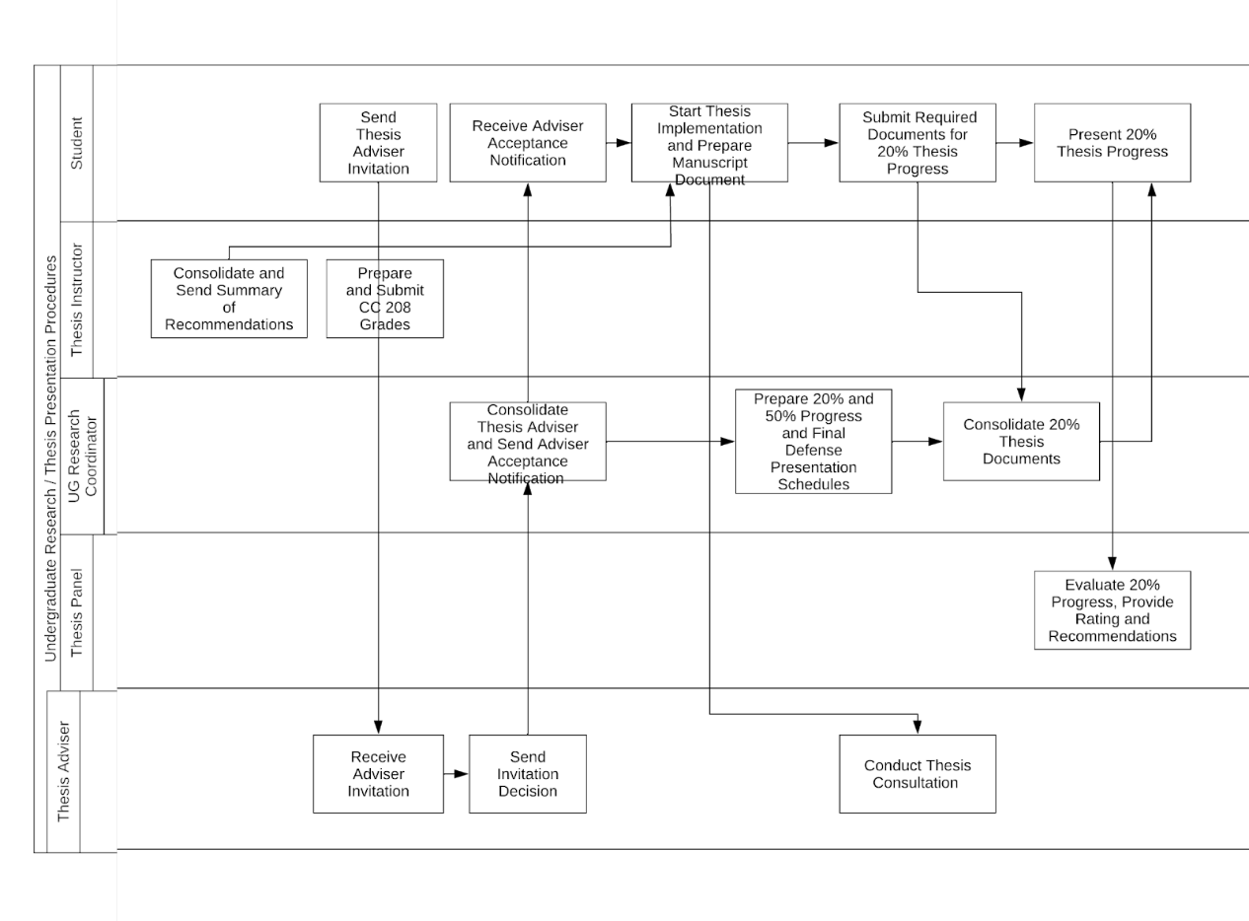

**Figure 5.** Procedural Design for the Thesis Adviser Invitation Process by R. Cabacas, 2022, Manual of Operations for CICT Undergraduate Research Unpublished

Figure 5 illustrates the invitation procedure for thesis advisers. Students are able to send an invitation to a potential thesis adviser. Eventually, advisors who receive an invitation will notify the student of their decision to accept or decline the invitation. Alternatively, if the thesis adviser declines the invitation, students may invite a different adviser.

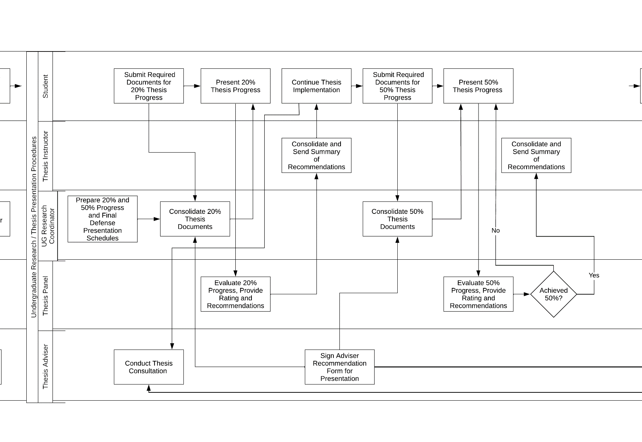

**Figure 6.** Procedural Design for the Presentation scheduling process by R. Cabacas, 2022, Manual of Operations for CICT Undergraduate Research Unpublished

Figure 6 presents the process of presentation scheduling in the system. The research coordinator consolidates the 20% progress of the students’ research, and the students present it to the panel. After presentation, the thesis panels evaluate and rate the 20% progress, and the thesis instructor consolidates and sends the summary of recommendations. The same process will repeat on the 50% progress presentation if the students achieve 50% progress. If students pass the 50% presentation, they will be enrolled in Thesis Writing 2.

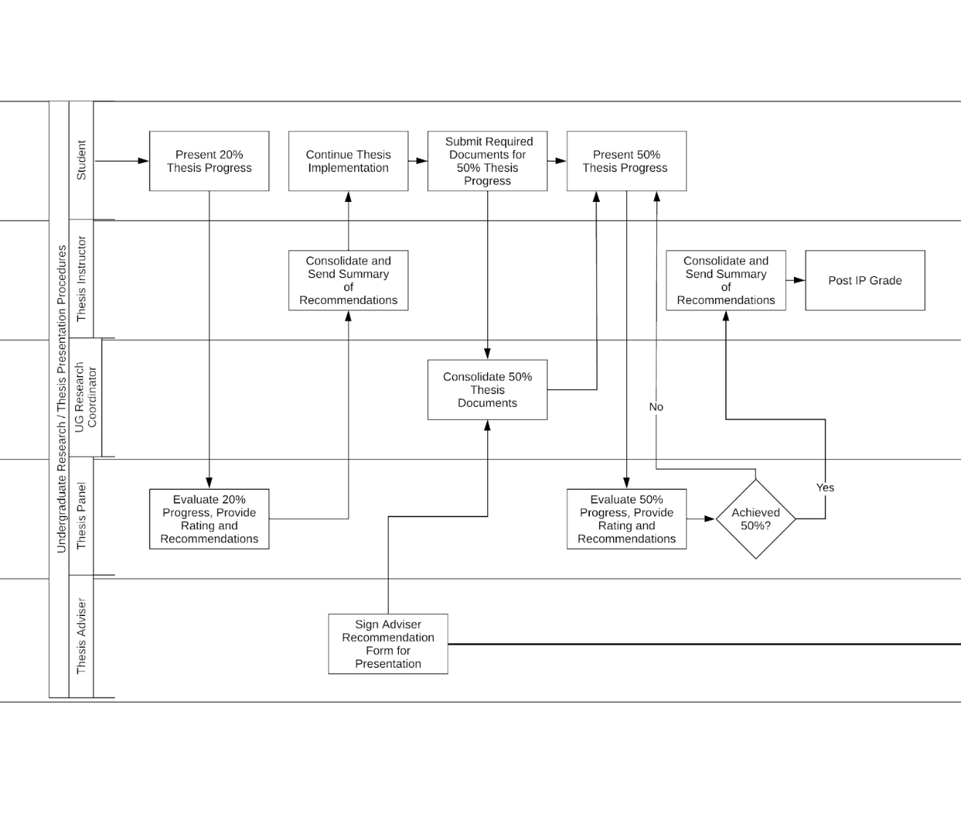

**Figure 7.** Procedural Design for the Thesis presentation process by R. Cabacas, 2022, Manual of Operations for CICT Undergraduate Research Unpublished

The proposed system's thesis presentation process is illustrated in Figure 7. Following the 20% presentation, the students proceed with their thesis work. If the students attain a 50% progress, the identical procedure as the one utilized during the 20% progress presentation will be replicated. Enrollment in Thesis Writing 2 is contingent upon the successful completion of the presentation with a minimum score of 50%.

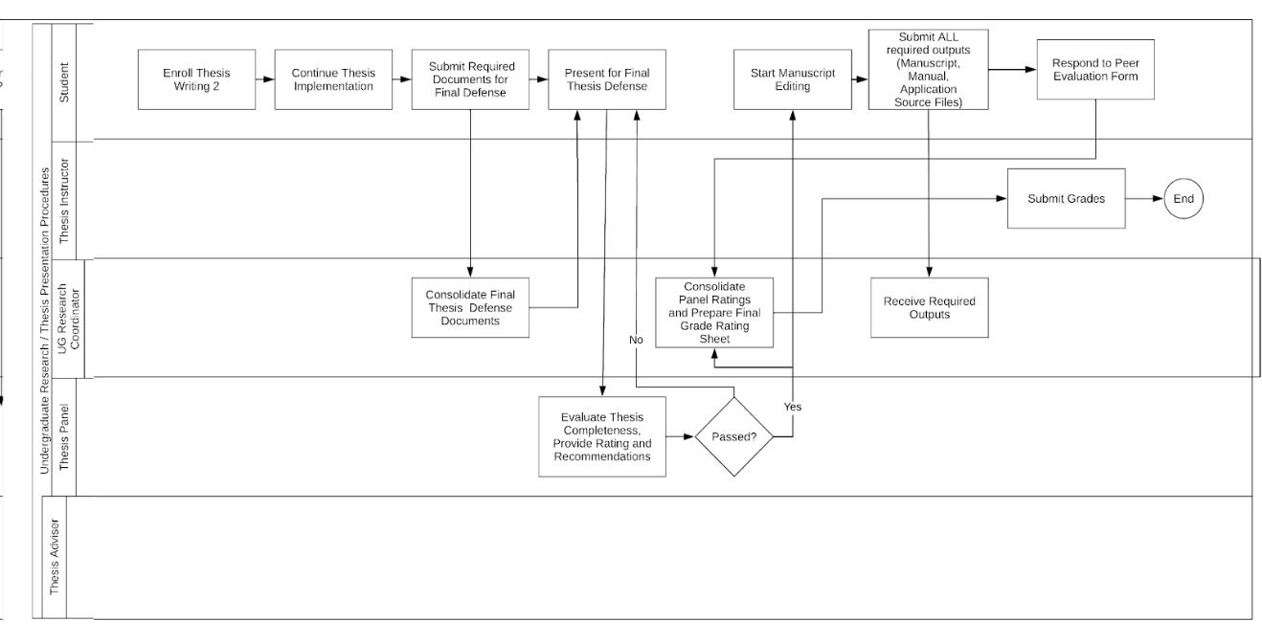

**Figure 8.** Procedural Design for the Progress monitoring process by R. Cabacas, 2022, Manual of Operations for CICT Undergraduate Research Unpublished

The progress monitoring of the proposed system is depicted in Figure 8. Upon registration for Thesis Writing 2, students proceed with the implementation of their thesis and furnish the necessary paperwork for the ultimate defense, which will be compiled by the research coordinator. Subsequently, the individuals will advance to deliver their thesis for the ultimate assessment, which will be scrutinized by the panels. Upon successful completion of the assessment, the individual will commence the process of manuscript editing and subsequently furnish the research coordinator with all the necessary deliverables.

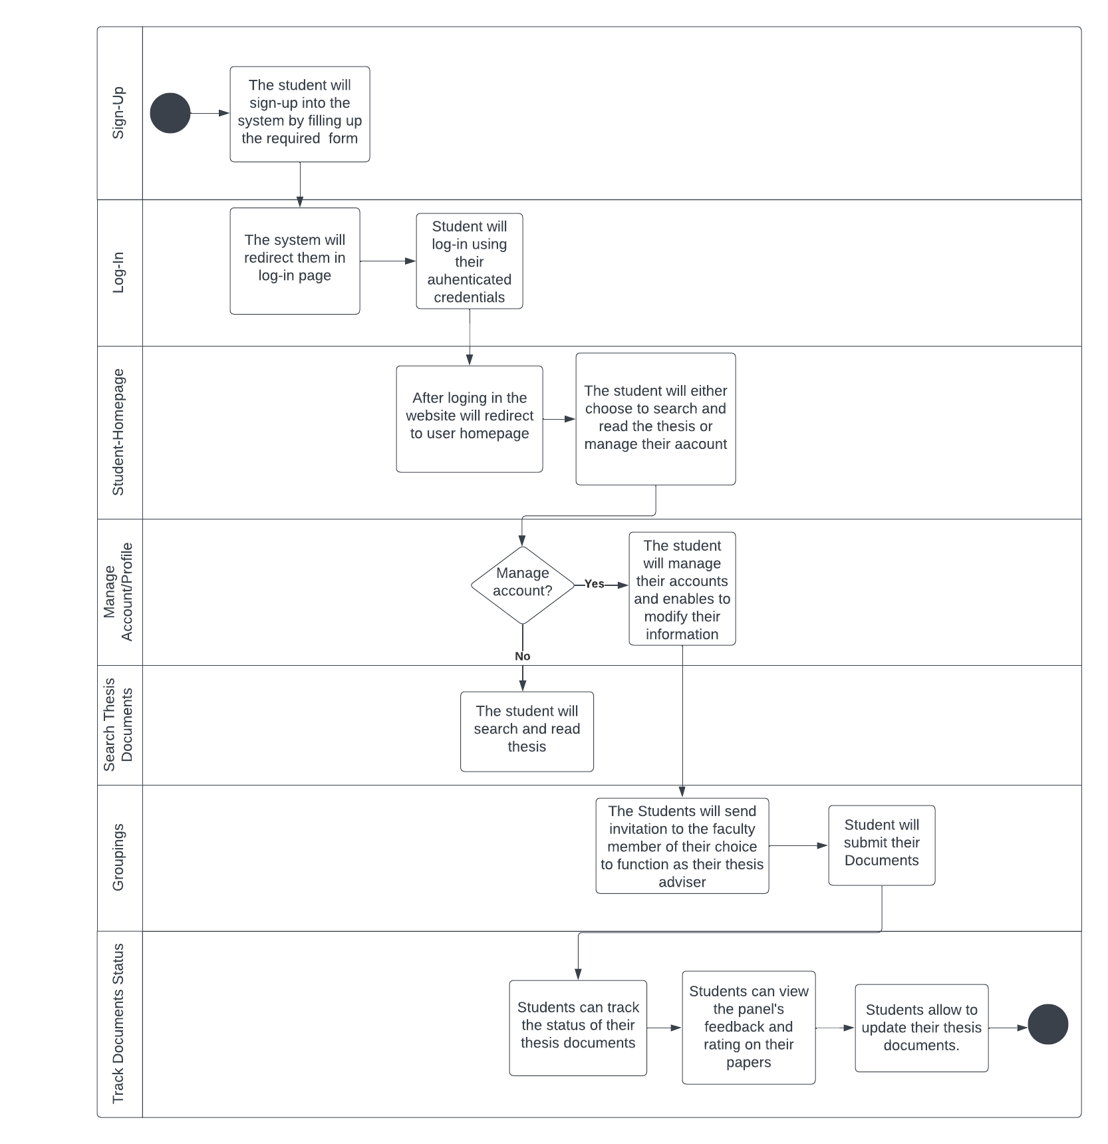

**Figure 9.** Student Activity Diagram

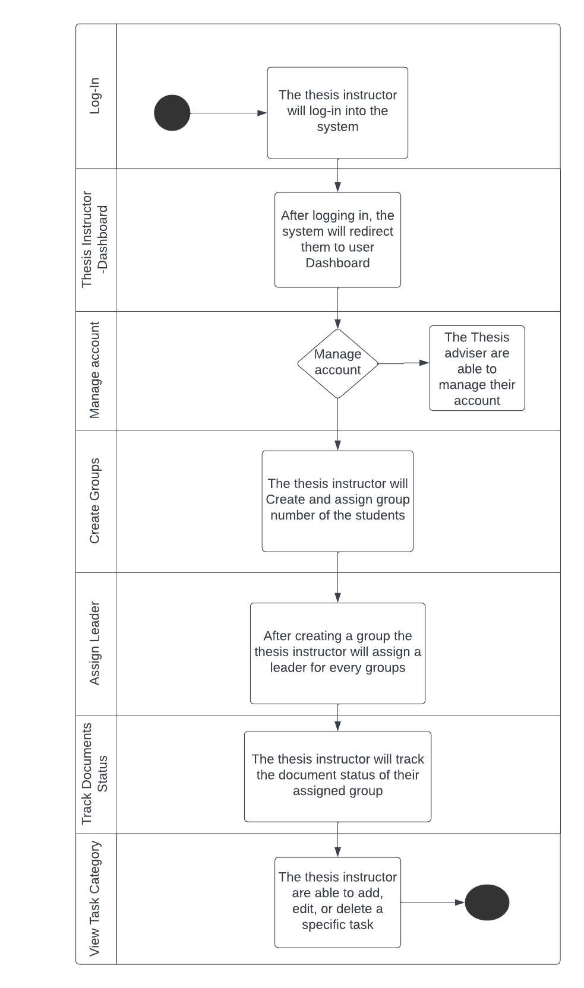

**Figure 10.** Thesis Instructor Activity Diagram

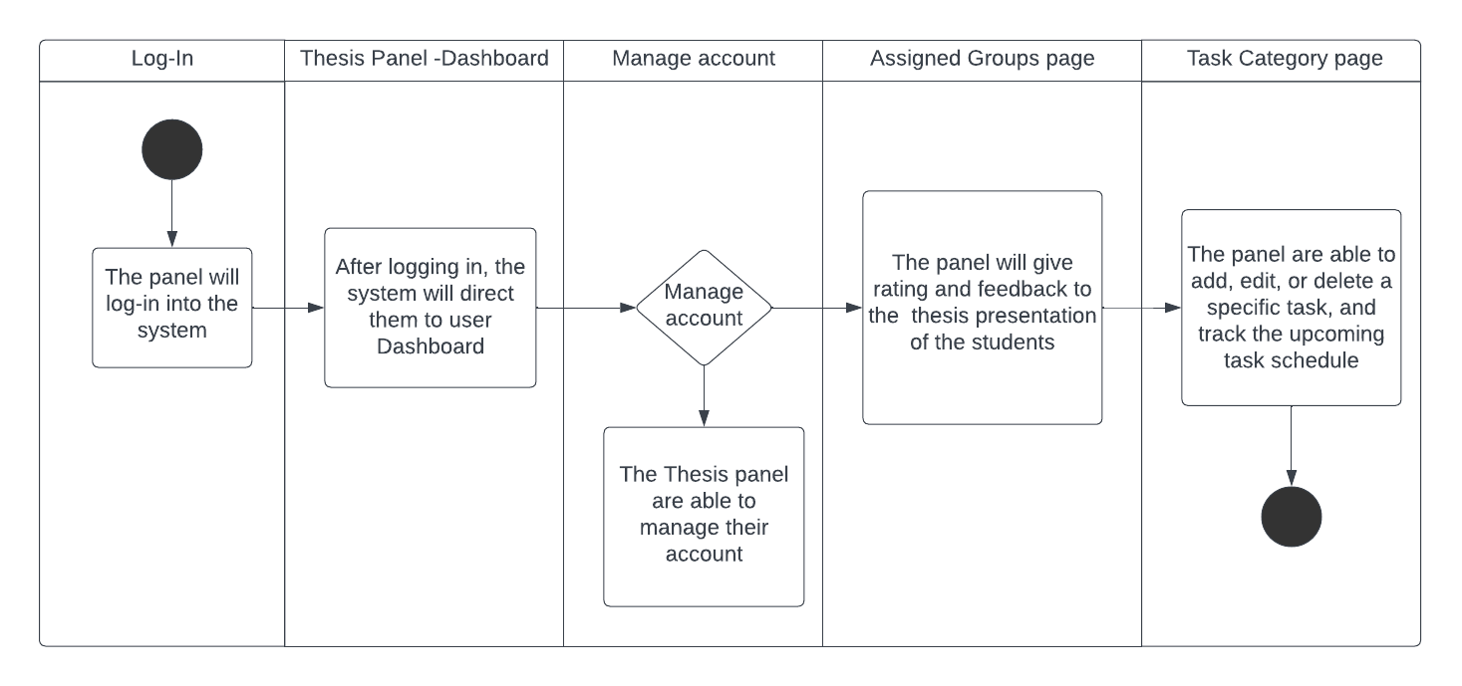

**Figure 11.** Panel Activity Diagram

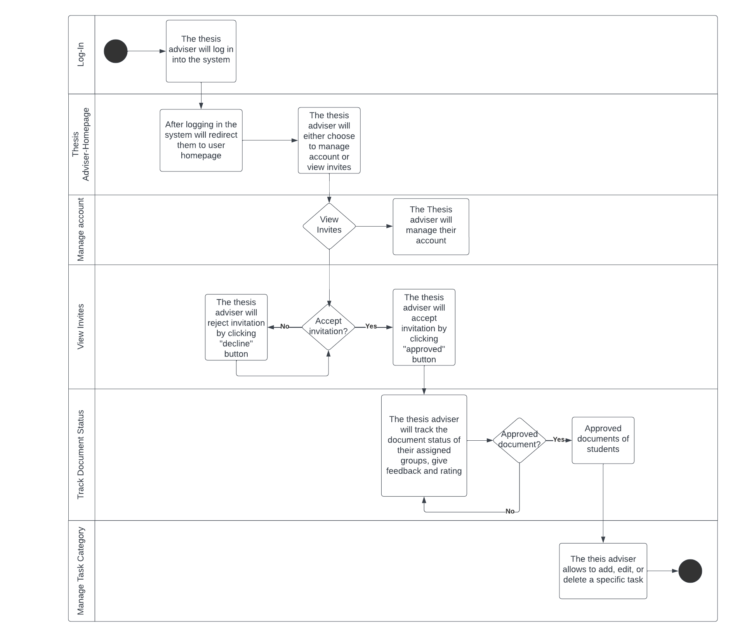

**Figure 12.** Thesis Adviser Activity Diagram

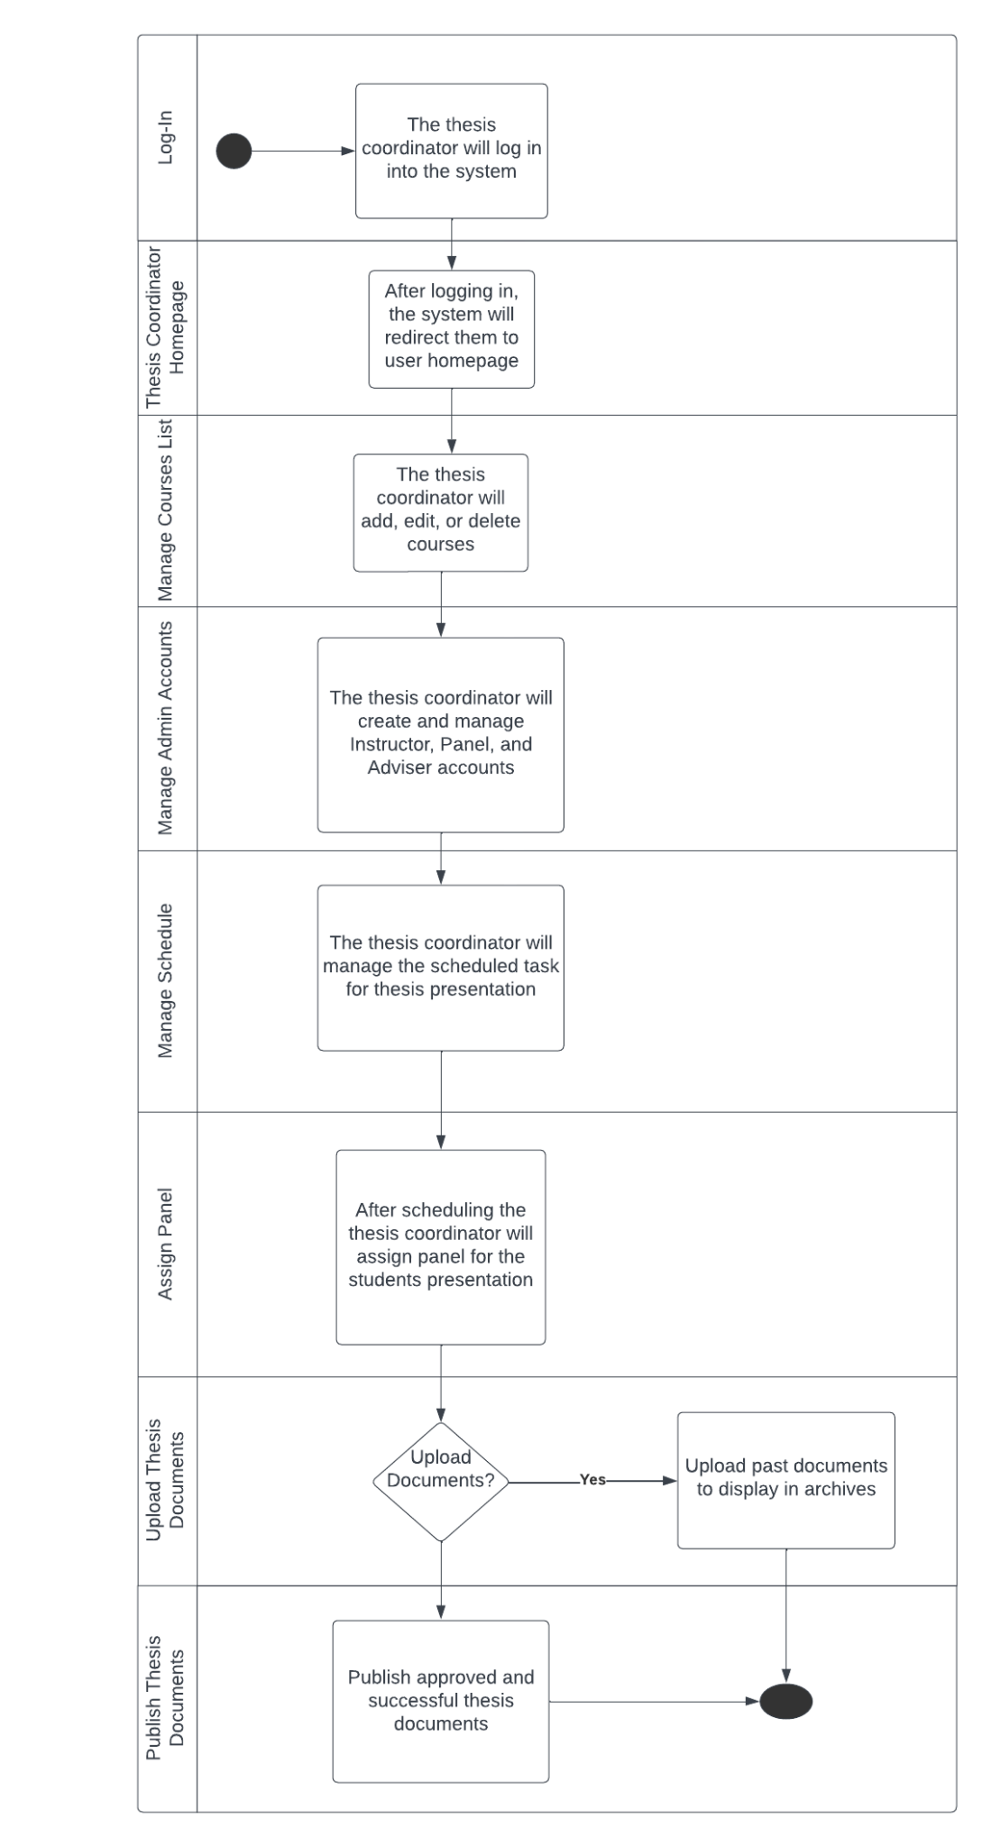

**Figure 13.** Thesis Coordinator Activity Diagram

**Level 0 Diagram of the Proposed System**

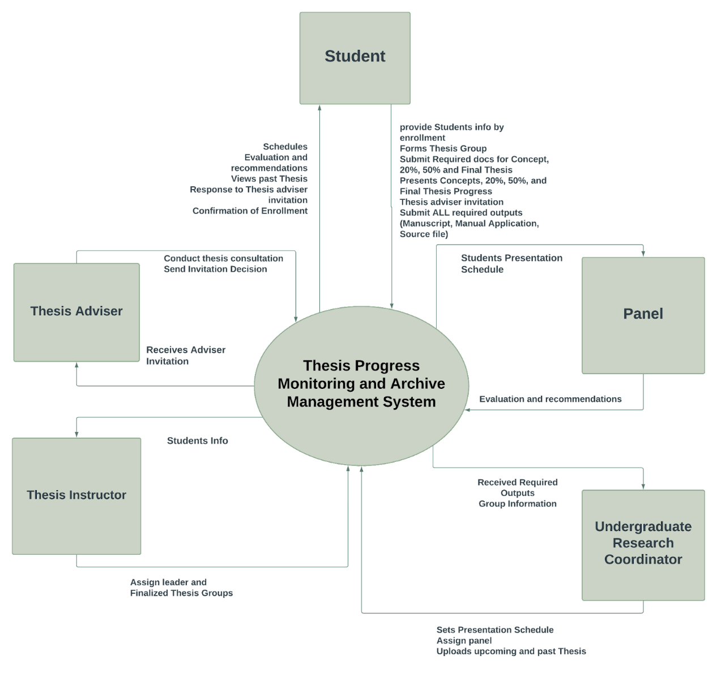

**Figure 14.** Context Diagram of the Thesis Progress Monitoring and Archive Management System

The diagram presented in Figure 14 represents the context diagram, which is commonly referred to as the level 0 diagram. The representation portrays the system as a unified process that maintains connections with entities outside of its boundaries. The representation illustrates the complete system as a unified bubble, wherein the incoming and outgoing arrows symbolize the input and output data, respectively. To register in the system, students provide their personal information. Students have the option to establish thesis groups and furnish the requisite paperwork for concept proposals (comprising 20%, 50%, and the ultimate thesis), in addition to a manuscript, a manual application, and a source file. Furthermore, it enables students to extend invitations to potential thesis advisors. Apart from accessing their academic timetables, assessments, and recommendations pertaining to their intended course of study, students also have the option to extend an invitation to a dissertation supervisor and peruse prior thesis papers.

The aforementioned system facilitates the process by which thesis advisors are able to receive invitations from their students, subsequently accepting or rejecting said invitations, and ultimately engaging in meetings with said students to discuss the content of their respective theses.

The student data is transmitted to the thesis instructor, who subsequently gains access to the finalized groups.

The individual responsible for overseeing undergraduate research has the ability to establish timetables for presentations, allocate multiple panels simultaneously, and upload both forthcoming and past thesis documents onto the platform. The system facilitates the acquisition of student output by the research coordinator.

The system enables panelists to view the schedule of student presentations and provide evaluations and suggestions to the students.

Level 1 Diagram

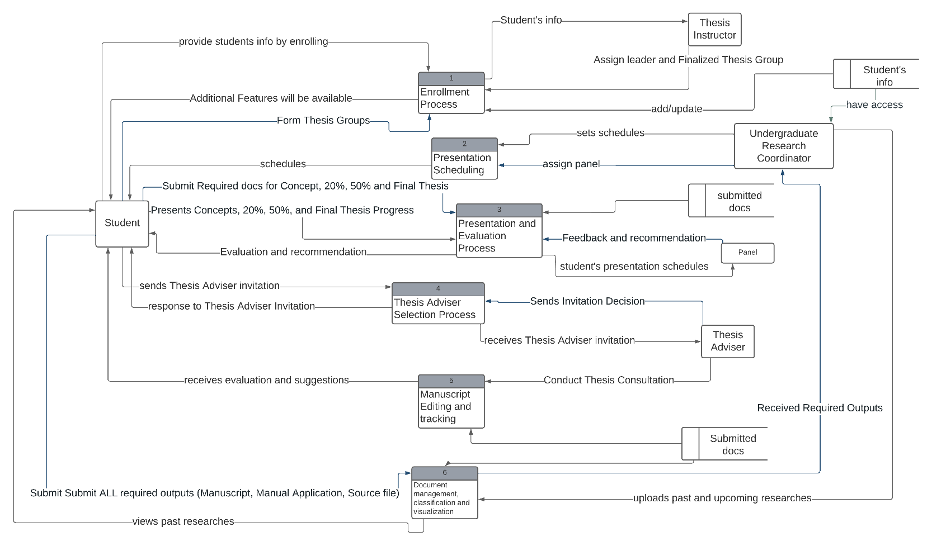

**Figure 15.** <Level 1 Diagram>

The diagram depicting level 1 of the system is illustrated in Figure 15. The process commences with the registration of a student, followed by the formation of enrollment groups, wherein the thesis instructor is granted access to student information. Finally, the enrollment groups are confirmed. The responsibility of assigning panels for student observation and organizing presentation schedules lies with the research coordinator. The academic process of presentation and evaluation entails the submission of documents, including a concept paper and the final thesis, by the student. The panels then provide feedback and recommendations on the student's presentation, which accounts for 20%, 50%, and the final thesis. The process of selecting a thesis advisor involves the student extending an invitation to the potential advisor, who then has the option to either accept or decline the invitation. The academic supervisor is capable of offering guidance on the manuscript presented by scholars to oversee the advancement of their investigation, encompassing the editing and monitoring of the manuscript. Document management, classification, and visualization include the research coordinator uploading past and upcoming thesis documents for students to view.

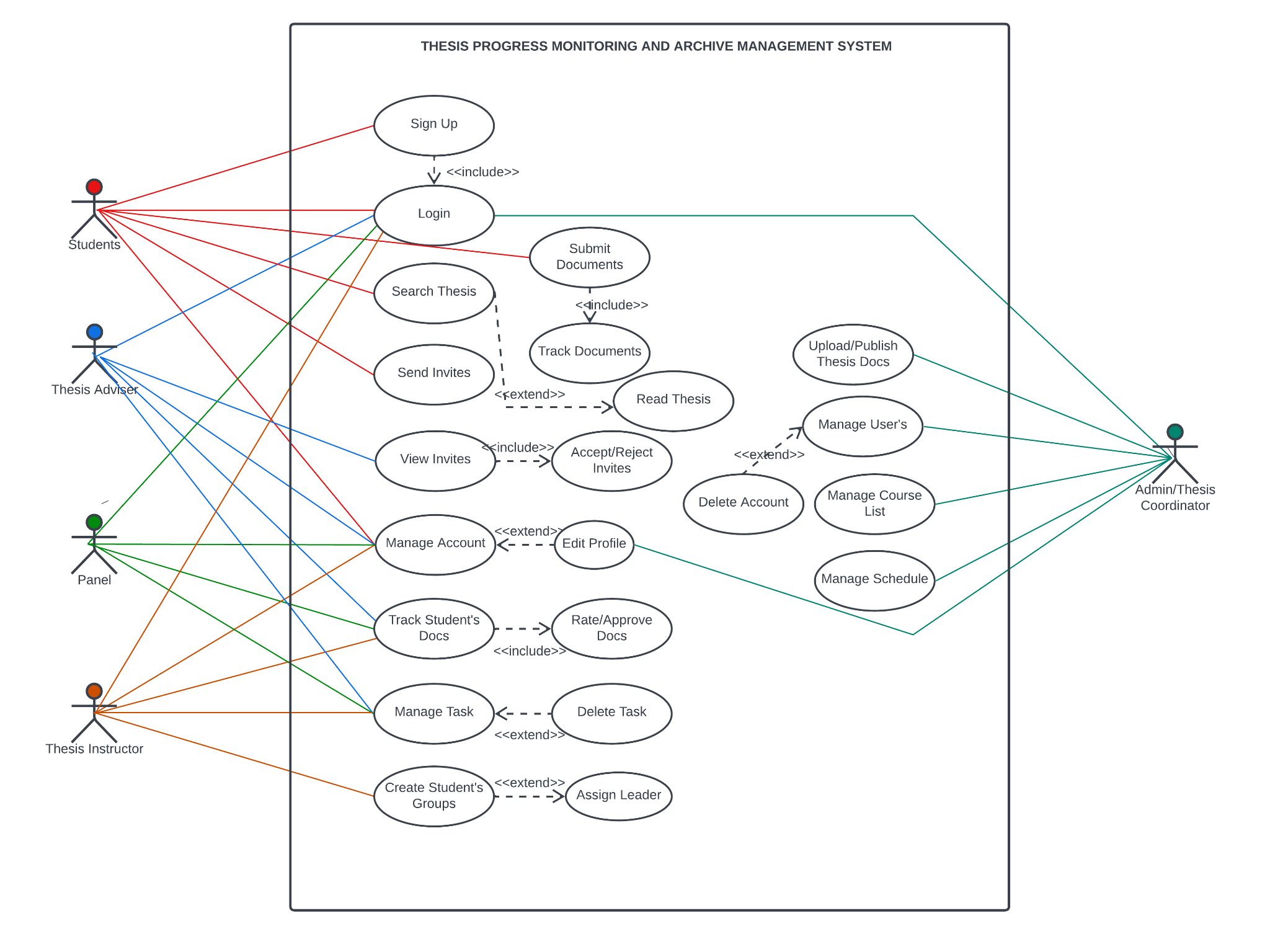

**Figure 16.** Use Case Diagram of the System

System Development Life Cycle

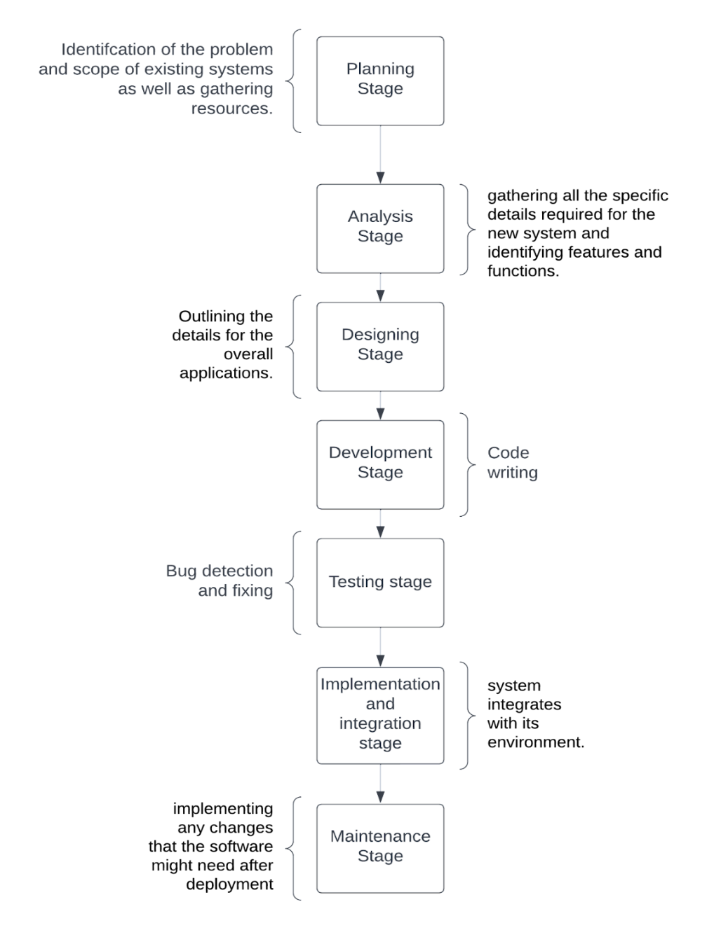

**Figure 17.** SDLC Model of the proposed System

*Planning Stage*

The escalating volume of completed research by students has led to a concomitant challenge in storing and conserving research documents. Amidst the pandemic, accessing and borrowing previous research projects can be challenging without physically visiting the library. The restricted nature of communication between thesis advisers and students poses a challenge for advisers to effectively monitor the progress of their students' theses. The current system exhibits a deficiency in monitoring functionalities and places a greater emphasis on archiving, in contrast to the proposed system which provides both monitoring and archiving capabilities. The Department of Computer and Information Sciences and Engineering (CICT) will furnish fundamental data of the students alongside a catalog of preceding and forthcoming research undertakings executed by CICT students. These resources will be utilized in the present study.

*Analysis Stage*

The proposed system entails various functions and features, including the ability to assign student groups, generate presentation schedules, and facilitate the submission of documents and approval of concepts. Additionally, the system provides a list of thesis advisers for selection, invitation acceptance or rejection, and adviser notification. It also enables the tracking of progress presentations and the editing of thesis manuscripts. Furthermore, the system automatically classifies documents based on their research area.

*Designing Stage*

This is where we outline the details for the overall system.

*Development Stage*

This is where we start to write code and build the system.

*Testing Stage*

At this point, the system is undergoing bug testing and subsequent debugging. The program will undergo a comprehensive evaluation during the testing phase, wherein any potential issues or imperfections will be identified, documented, rectified, and subsequently subjected to further testing.

*Implementation and Integration Stage*

Upon completion of the testing phase, the software's comprehensive design will be finalized. The integration and eventual installation of the information system into its environment will take place. Upon completion of this phase, the software is deemed to be potentially marketable and can be disseminated to any final consumer.

*Maintenance Stage*

Practicing any activities required to handle issues reported by end users and implement any changes that the software may require after deployment during the maintenance stage.

# CHAPTER 4 RESULTS AND DISCUSSION

## Implementation

The system's development employed the utilization of two servers: the MySQL Server, a database management system that boasts exceptional data structure, connection, and platform compatibility, and the Apache HTTP Server, a cross-platform web server software that is both free and open-source and is provided under the Apache License 2.0. The primary programming language utilized in the system is PHP 7.4, which is currently considered the latest stable iteration of the language. Furthermore, the system was developed utilizing JavaScript, CSS, and HTML on the front-end, while PHP was employed on the back end. The system in development underwent testing utilizing XAMPP.

Here are some broad guidelines for XAMPP hardware requirements:

Processor (CPU): Although XAMPP can run on a range of processors, a faster processor with several cores can provide greater performance, particularly when running resource-intensive applications.

Memory (RAM): The quantity of RAM required is determined by the size and complexity of the web applications being run. For basic development, 2GB of RAM should enough, but for more demanding projects, 4GB or more may be required.

Storage (Hard Drive): XAMPP does not require a lot of disk space, but the size of your web applications and databases will determine how much storage you need. Make sure you have enough free space for your projects and data.

XAMPP is compatible with the following operating systems: Windows, macOS, Linux, and Solaris. Check that your hardware is compatible with the operating system you wish to use.

Network Access: XAMPP can be accessed locally or remotely. If you intend to access your online applications from other devices, make sure you have a network adapter or Wi-Fi connectivity.

*System Inputs and Outputs*

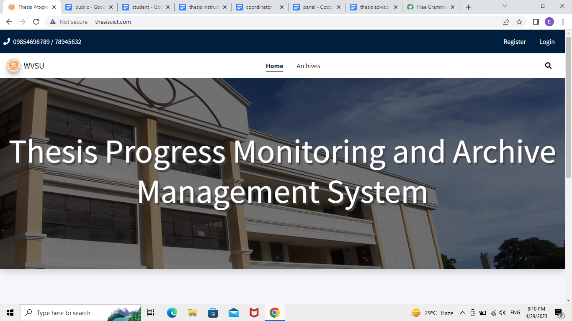

**Figure 18.** Start screen interface.

Users can gain access to their accounts by utilizing the login and register functionalities available on the public home page interface of the system. Additionally, this interface serves as a platform for users to create new accounts and navigate published theses that are stored in the archives.

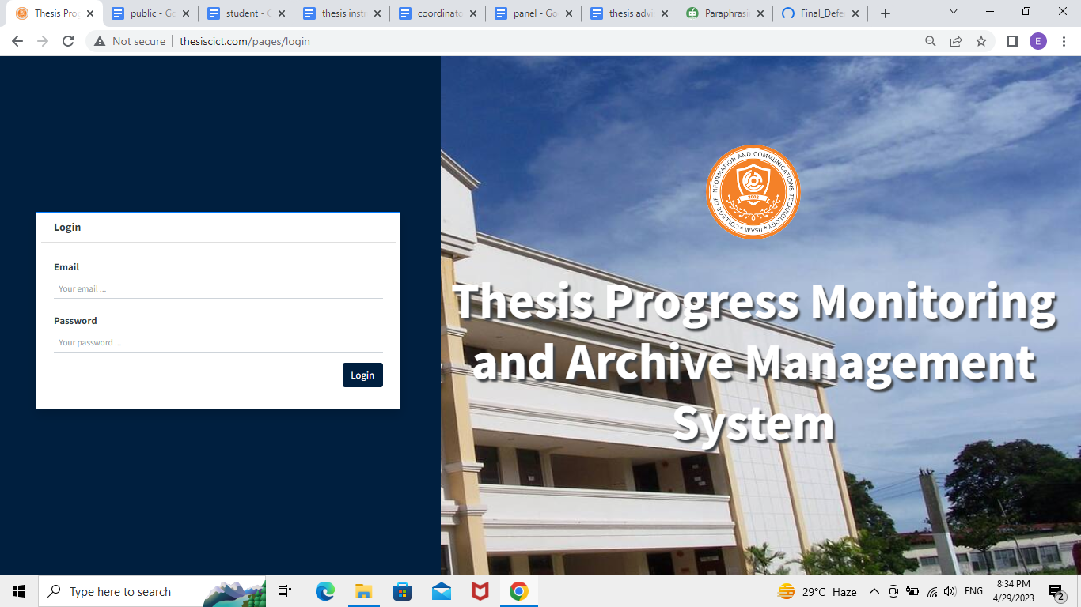

**Figure 19.** Login Screen Interface

The login screen interface facilitates user authentication by providing a means for users to input their email and password credentials, thereby granting access to their respective accounts.

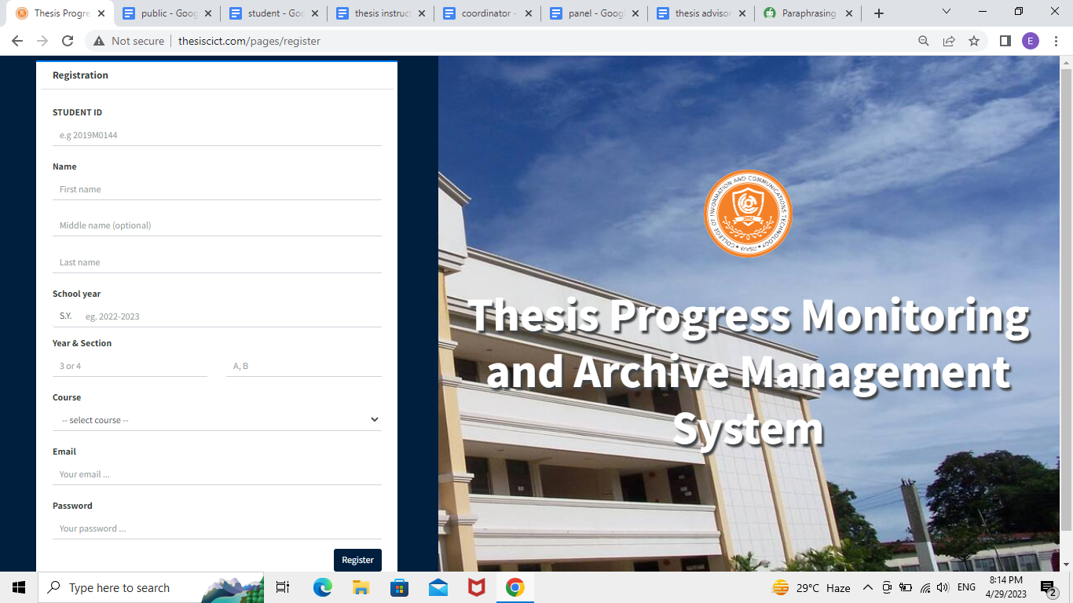

**Figure 20.** Registration screen interface for students

The registration screen interface for students allows for the creation of a user account by inputting various personal details, including the student's identification number, full name, academic level, preferred password, email address, as well as the course, year, and section of enrollment.

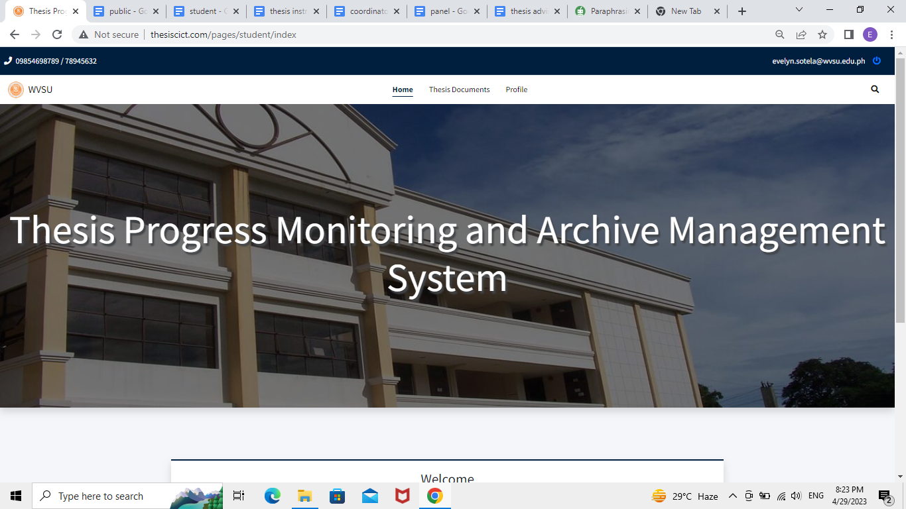

**Figure 21.** Home screen interface of students

Home screen interface of students, where they see the navigation button for thesis documents and profiles.

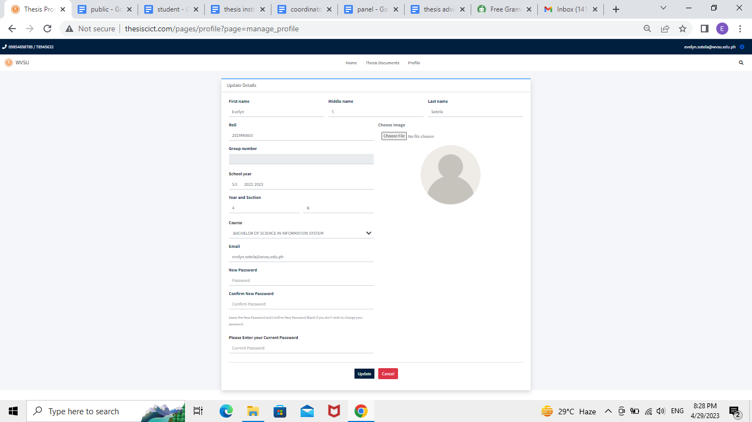

**Figure 22.** Students profile screen interface

The profile screen interface enables students to modify or revise their information. Additionally, users have the option to upload a photograph of themselves to facilitate the process of identification.

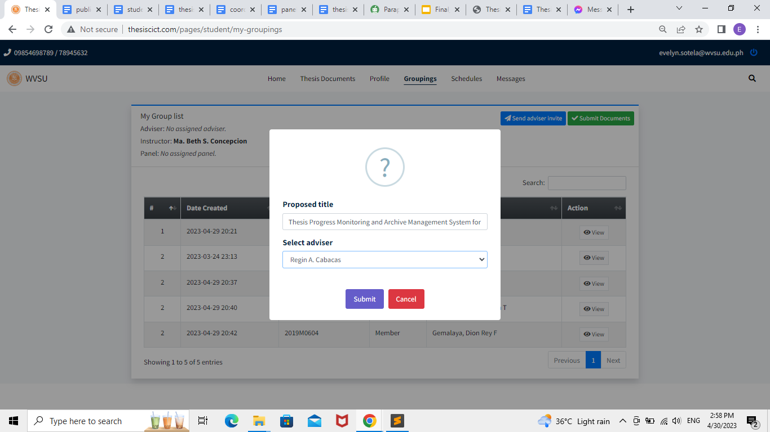

**Figure 23.** Groupings option Screen Interface

The interface of the student's home page screen features a "Groupings" option that enables them to extend an invitation to the faculty member of their choice to function as their thesis adviser.

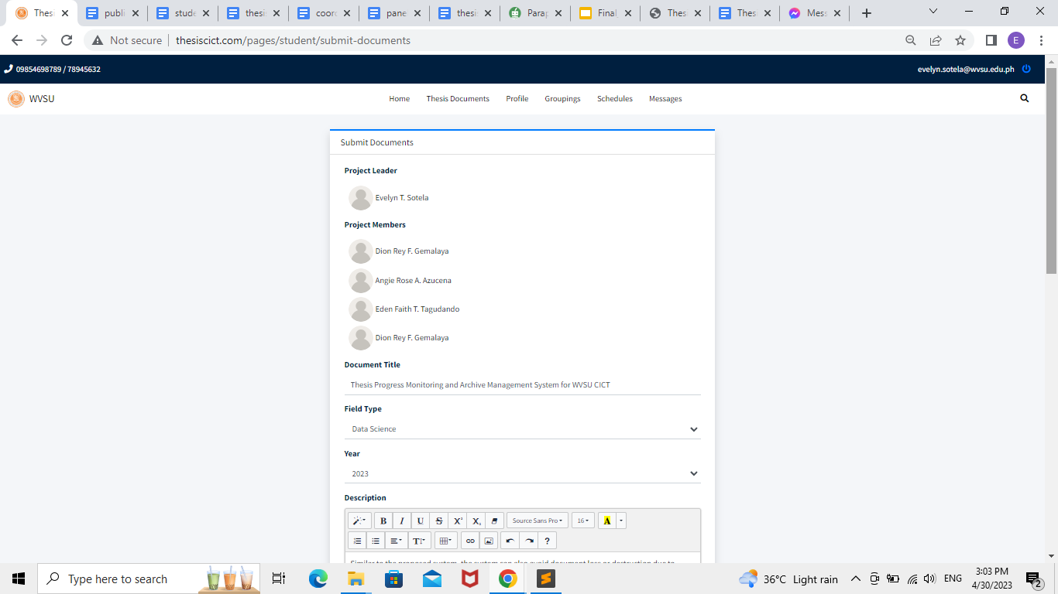

**Figure 24.** Document submission in Groupings option

Users have the option to submit their documents by selecting the "submit documents" button located within the "Groupings" feature.

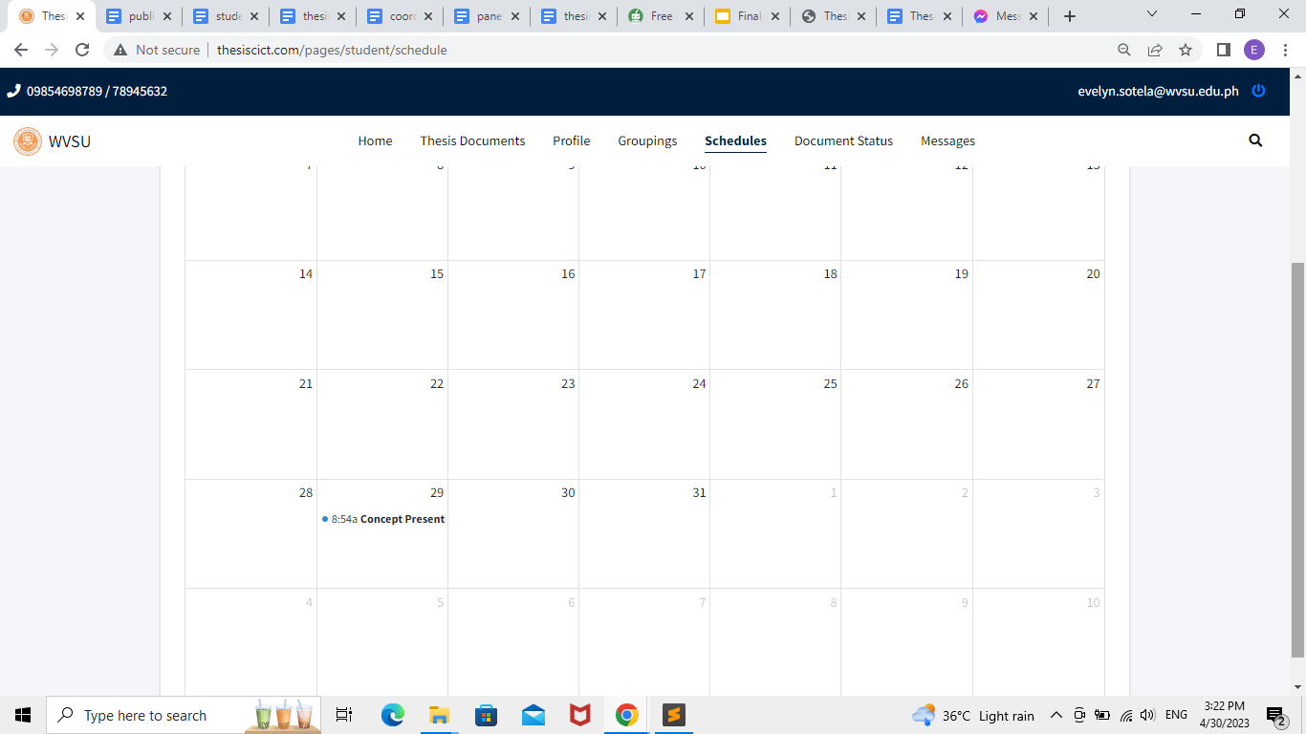

**Figure 25.** Schedule Screen Interface

The feature labeled as "Schedules" enables students to access and review their presentation schedule.

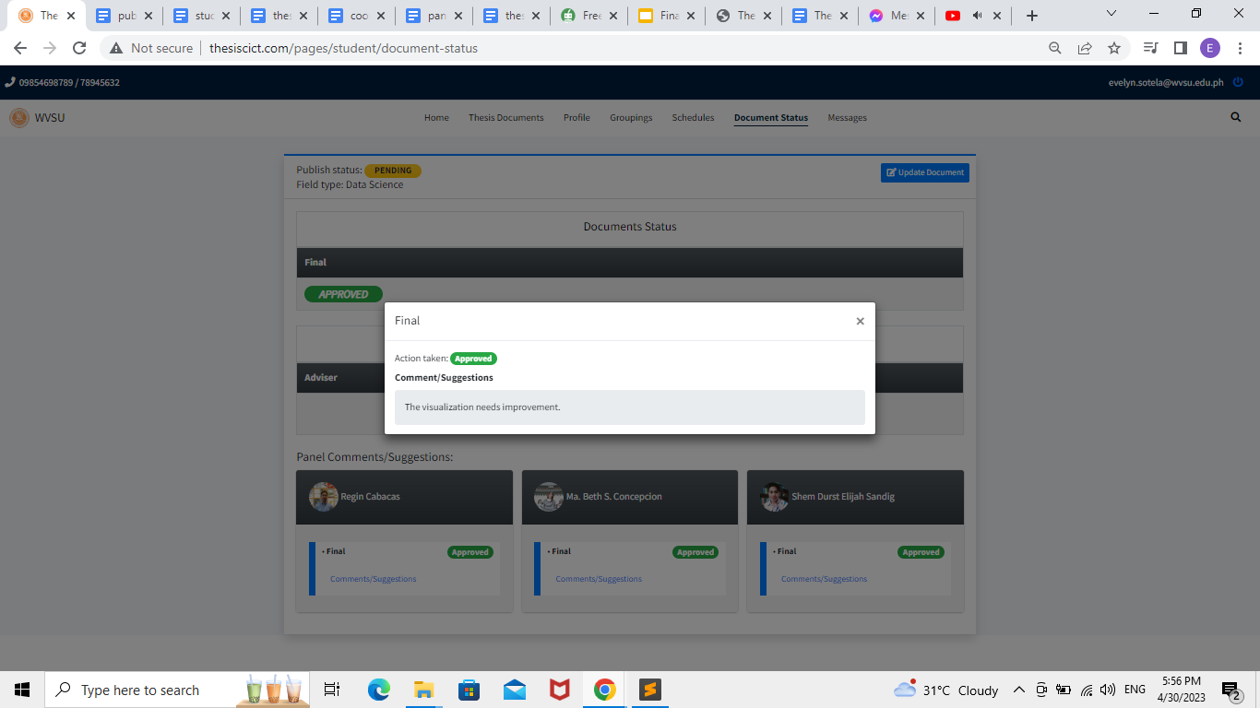

**Figure 26.** Document Status Screen Interface

The "Document Status" option allows the students to track the status of their document, and by clicking "update document," they can revise their papers. They can also view if the panels approved or disapproved their papers and view the panel's feedback.

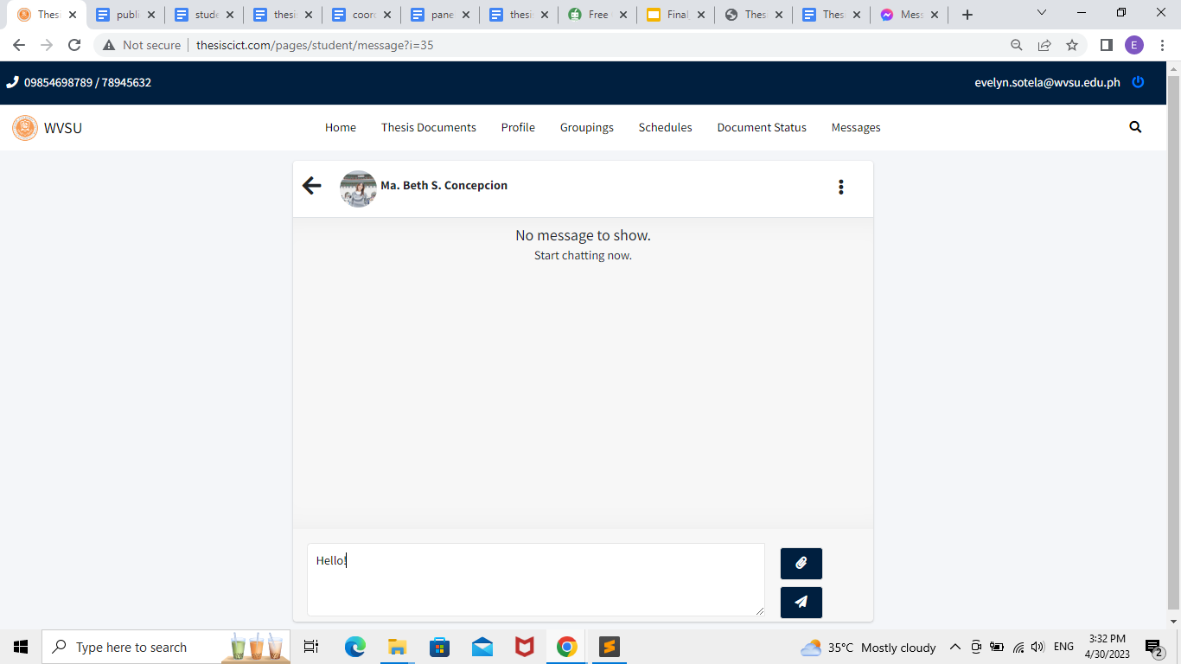

**Figure 27.** Message Screen Interface

The "Messages" option allows students to communicate with their assigned faculty.

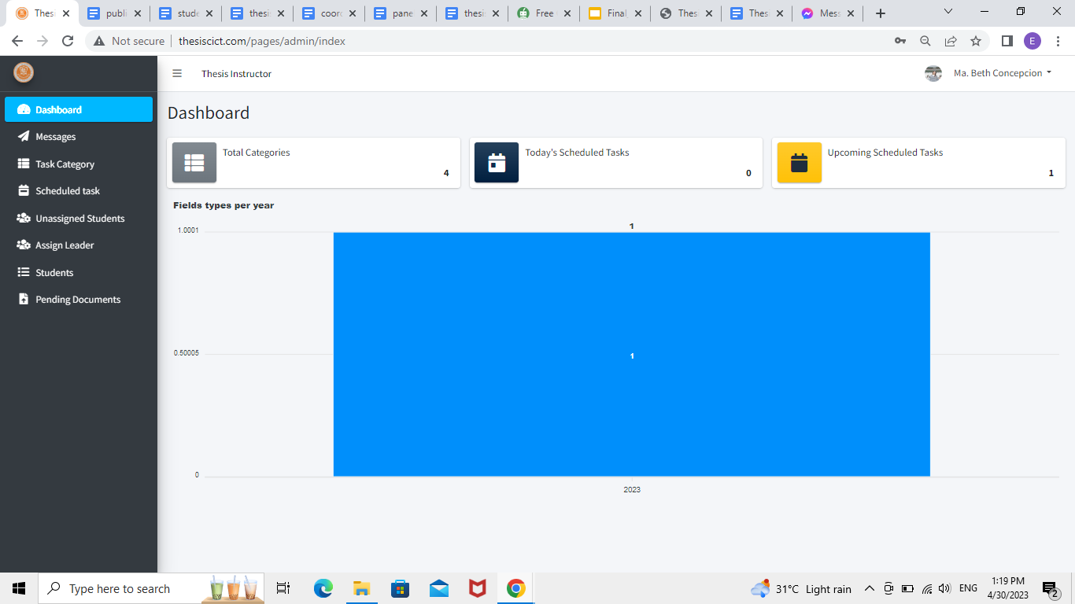**Figure 28.** Dashboard Screen Interface

The dashboard screen interface of the thesis instructor displays the categories, scheduled tasks, and upcoming tasks.

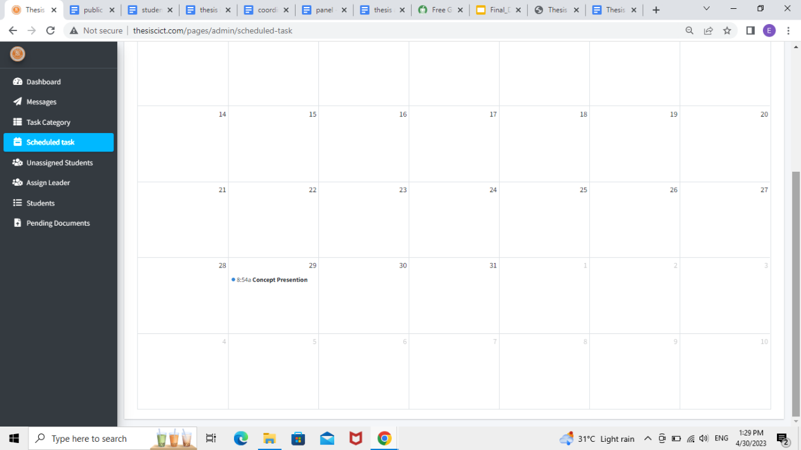

**Figure 29.** Scheduled task Screen interface

The "scheduled task" option allows the thesis instructor to track the schedule of upcoming thesis defenses and presentations.

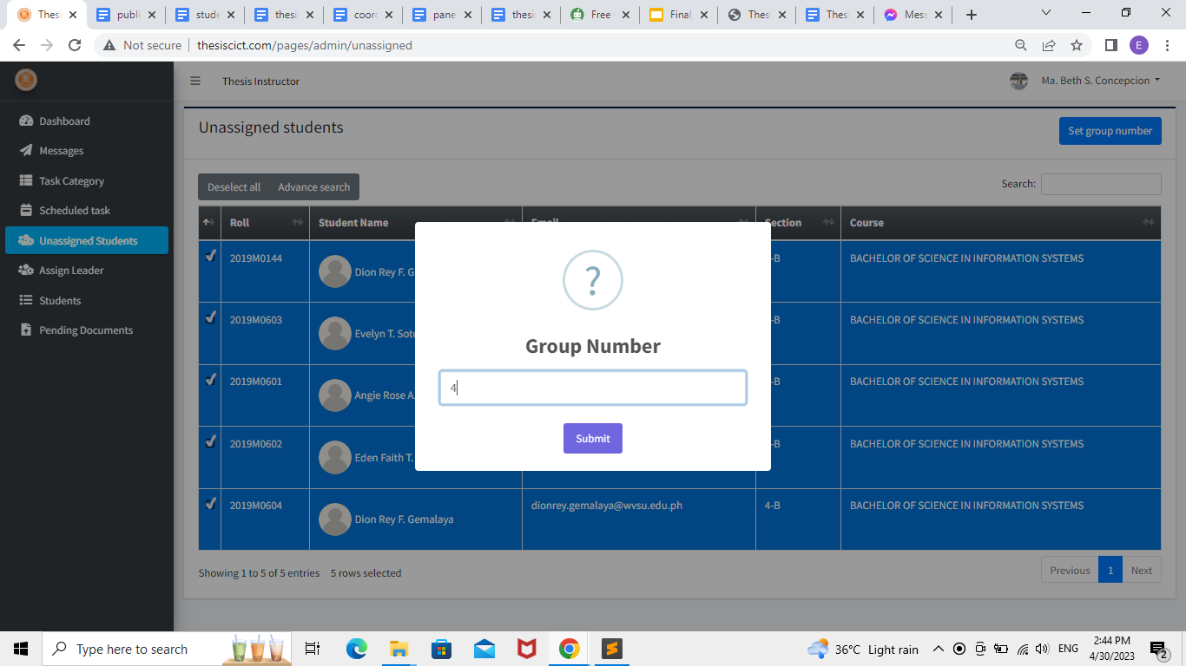

**Figure 30.** Unassigned students Screen Interface for thesis instructor

The "unassigned students" option allows the thesis instructor to create and assign the group number of the students.

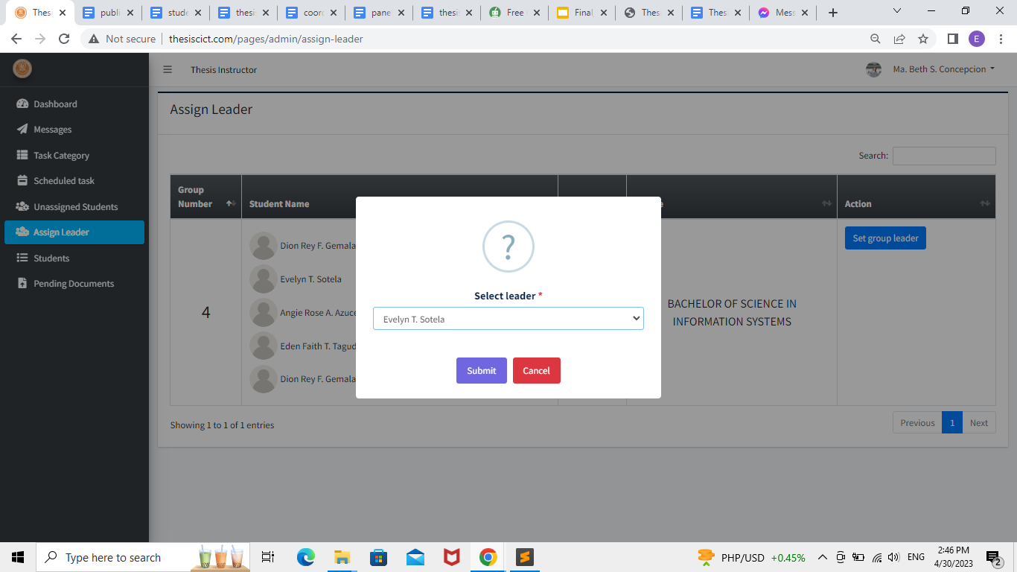

**Figure 31.** Assign Leader option Screen Interface for Thesis Instructor

The "Assign Leader" option allows the thesis instructor to assign the leader of the group.

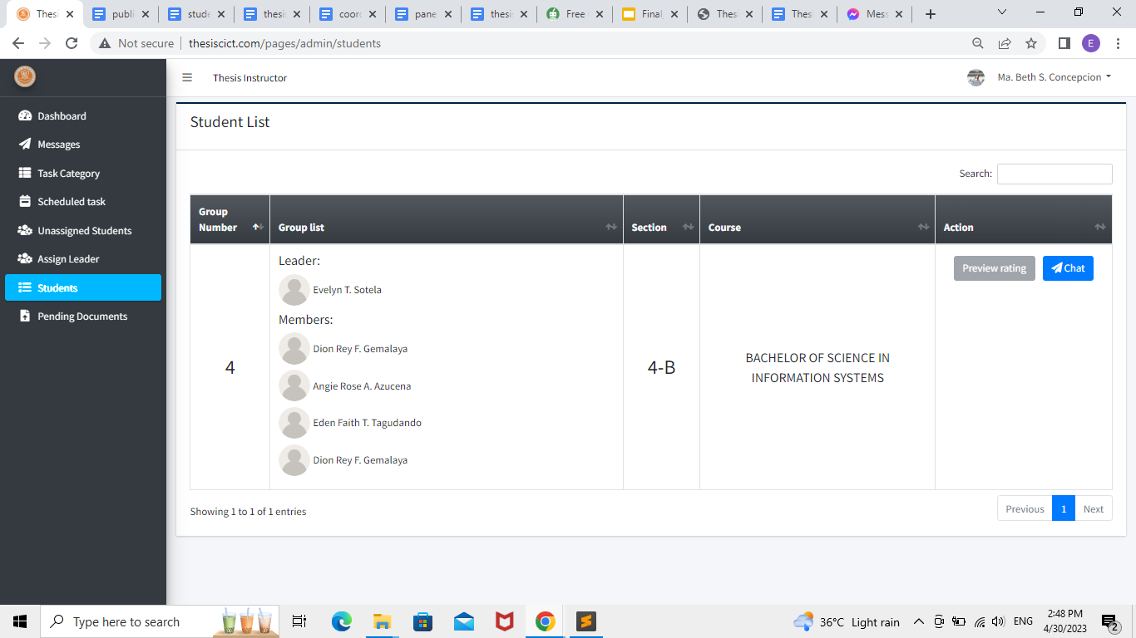

**Figure 32.** Student tab Screen Interface for Thesis Instructor

The "Student" option allows the thesis instructor to see the group of students that they supervise; there is also a message icon that allows them to connect with the group; and the "preview rating" option allows them to see the panel's rating of the group's presentation.

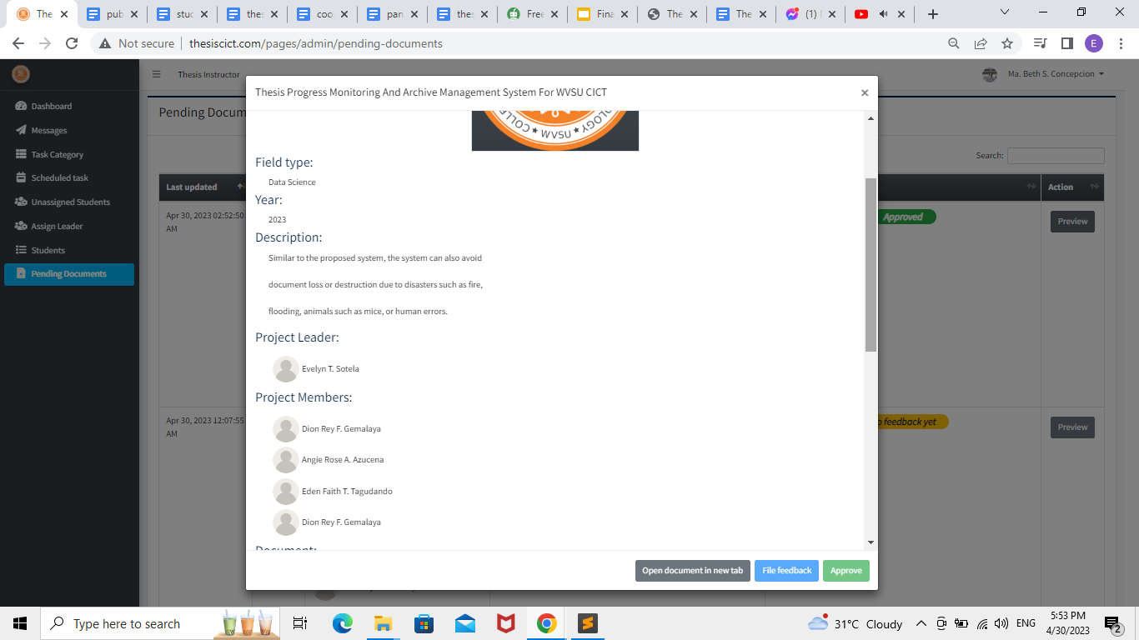

**Figure 33.** Pending Documents tab Screen Interface for Thesis Instructor

The "Pending Documents" option allows the thesis instructor to track the document status of their assigned group. It shows the group number and members, and they can also give their feedback and approve the document based on the decision of the panels.

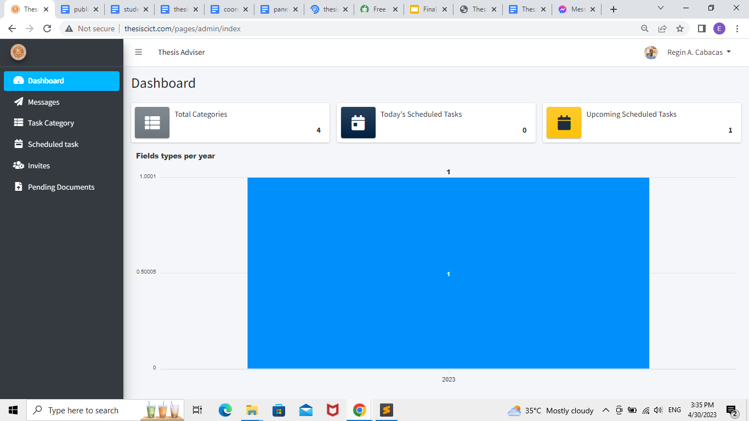

**Figure 34.** Thesis adviser home screen interface

Home screen interface of the thesis adviser, in which the user can access different functions of the system.

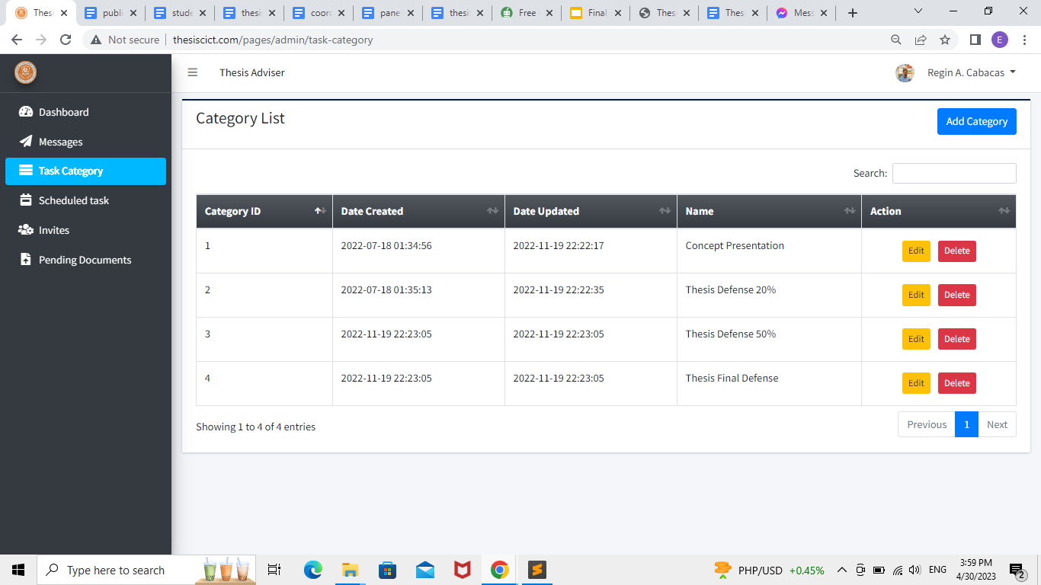

**Figure 35.** Task Category tab Screen Interface for Thesis Adviser

The "task category" option allows the thesis adviser to add, delete or edit a specific task in the system.

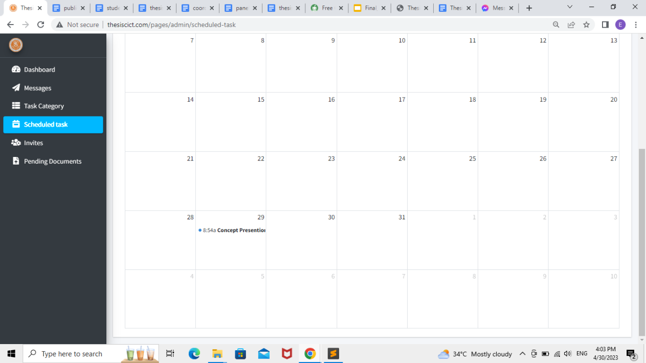

**Figure 36.** Scheduled Task tab Screen Interface for Thesis Adviser

The "scheduled task" option allows the thesis adviser to track the schedule of upcoming thesis defenses and presentations.

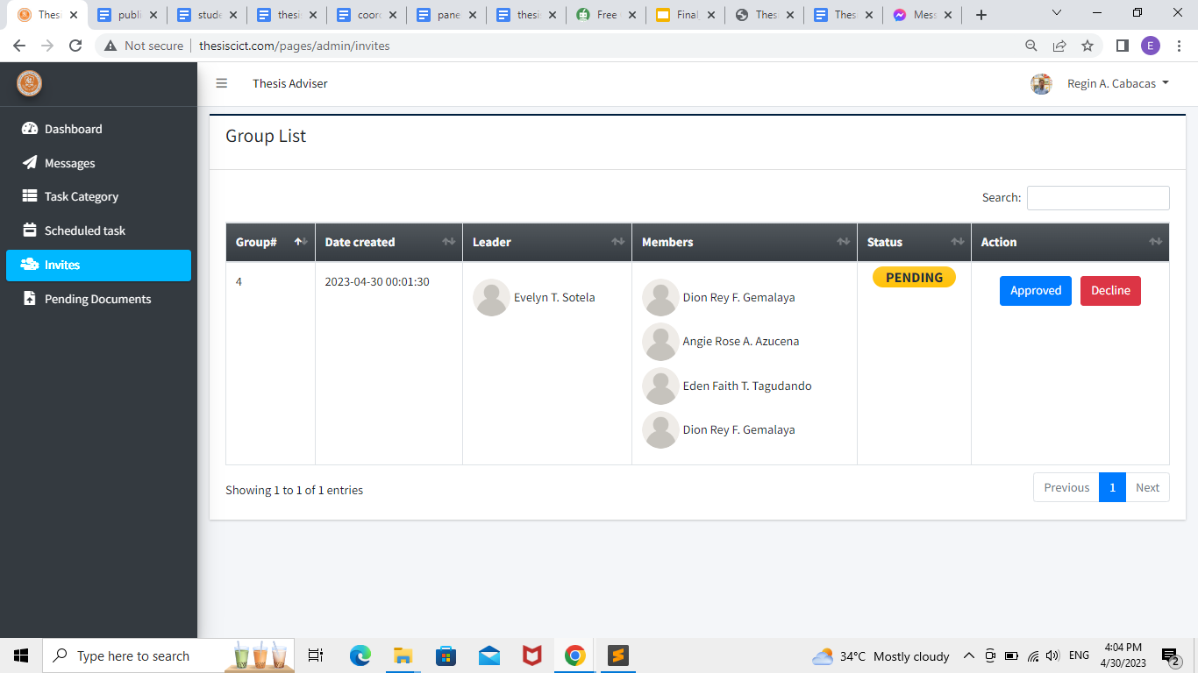

**Figure 37.** Invitation tab Screen Interface for Thesis Instructor

The "invites" option allows the thesis adviser to receive invitations from the students; the user can either accept or reject the invitation.

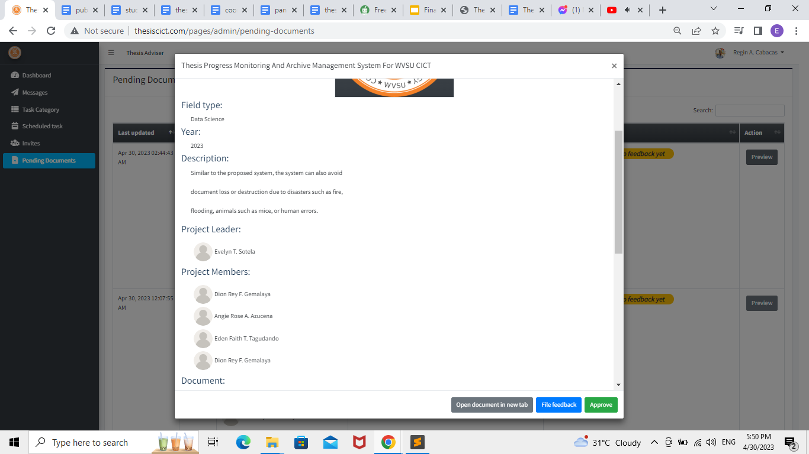

**Figure 38.** Pending Documents tab Screen Interface

The "Pending Documents" option allows the thesis adviser to track the document status of their assigned group. It shows the group number and members, and they can also give their feedback and approve the document based on the decision of the panels.

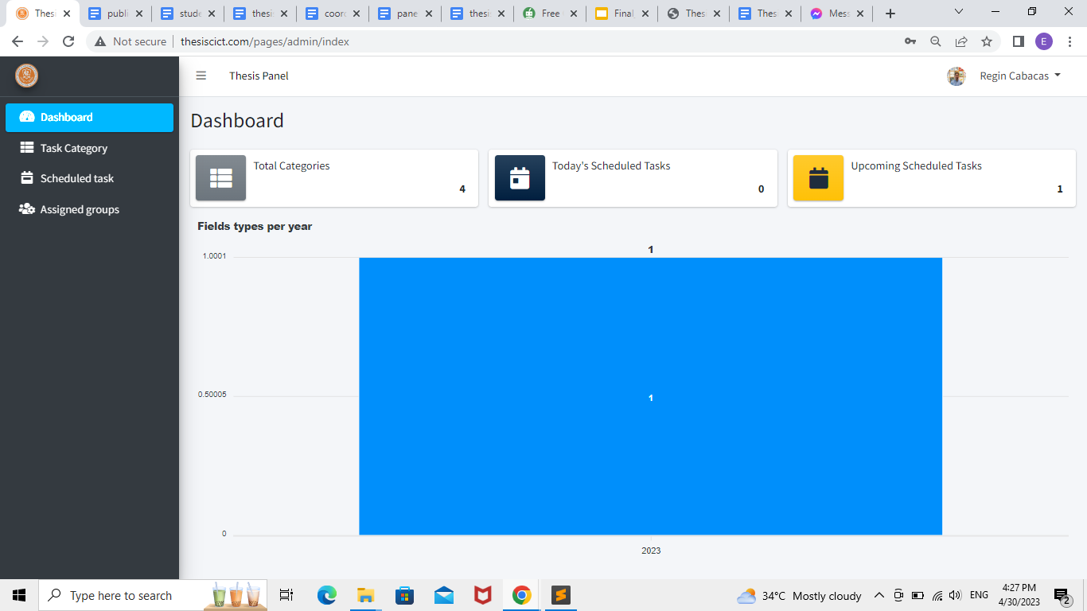

**Figure 39.** Panels home screen interface

Home screen interface of the panels, in which the user can access different functions of the system.

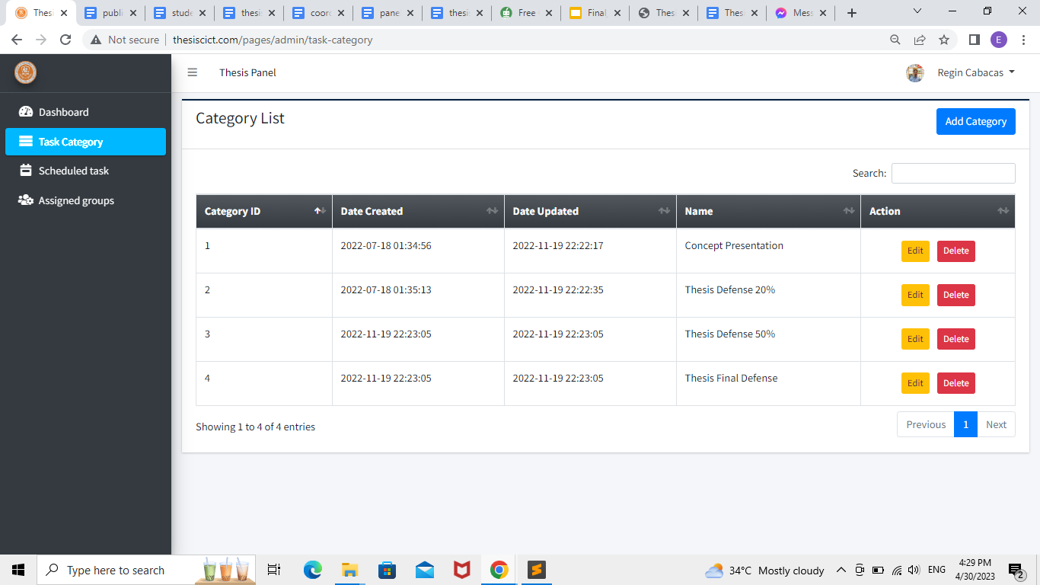

**Figure 40.** Task category tab

The "task category" option allows the panels to add, delete or edit a specific task in the system.

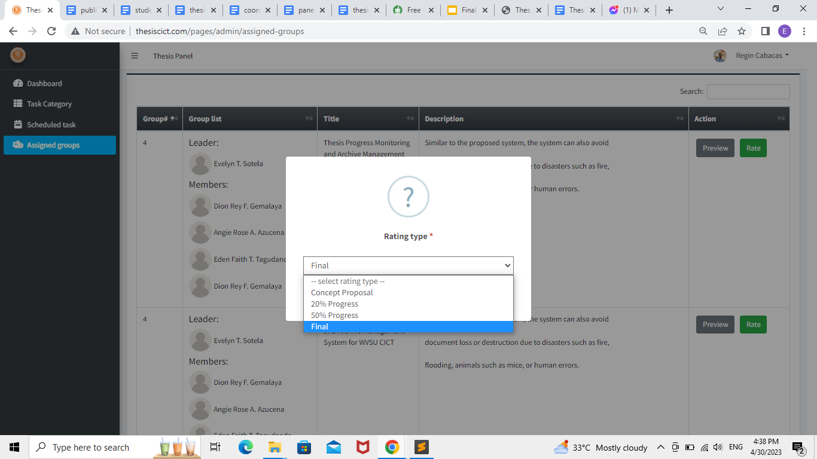

**Figure 41.** Assigned Groups tab Screen Interface

The "Assigned Groups" option allows the panels to view their assigned group; they can also rate the presentation and the documents of the group by clicking the "rate" button, in which they can also choose whether they want to rate the concept presentation, 20%, 50%, or the final thesis defense.

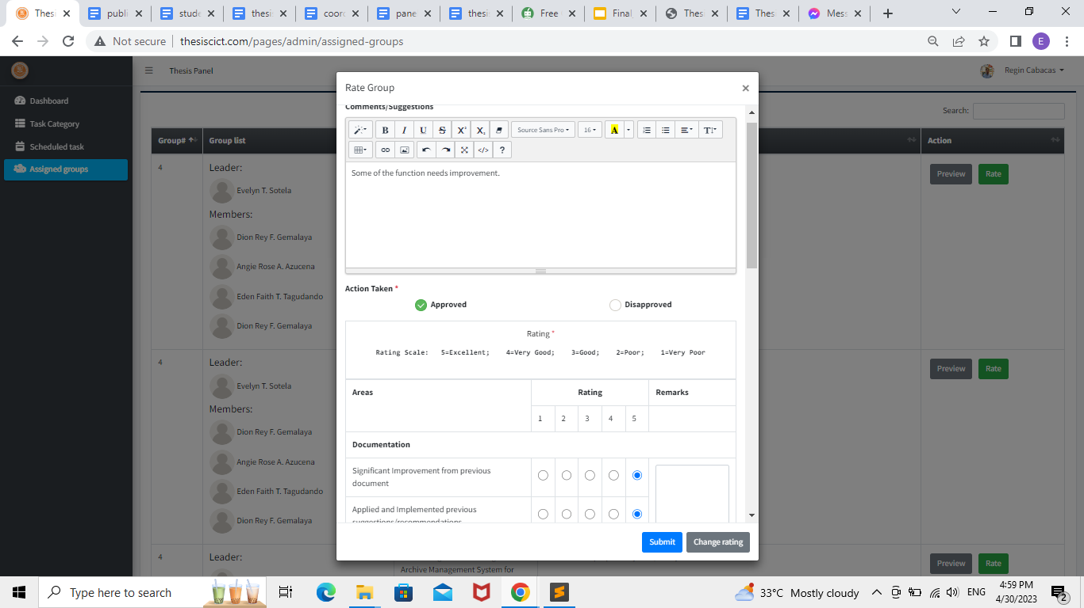

**Figure 42.** Rating Screen interface

By clicking the "Rate" button, the panels can input their comments or suggestions and give their rating from 5, which is the highest, to 1, which is the lowest.

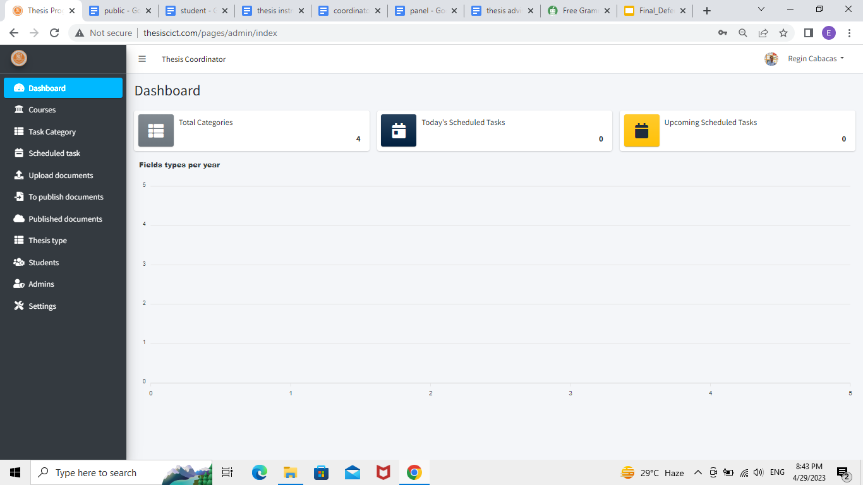

**Figure 43.** Thesis coordinator home screen interface

Home screen interface of the thesis coordinator, in which the user can access different functions of the system.

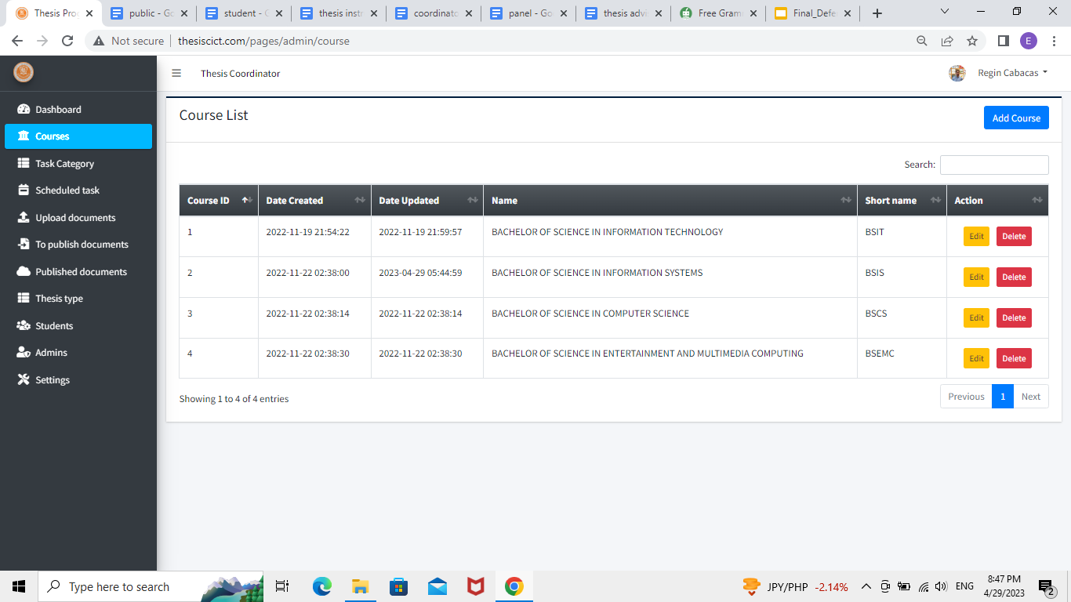

**Figure 44.** Course tab screen interface

Course screen interface, which allows the thesis coordinator to view, edit, add, or delete a certain course registered in the system.

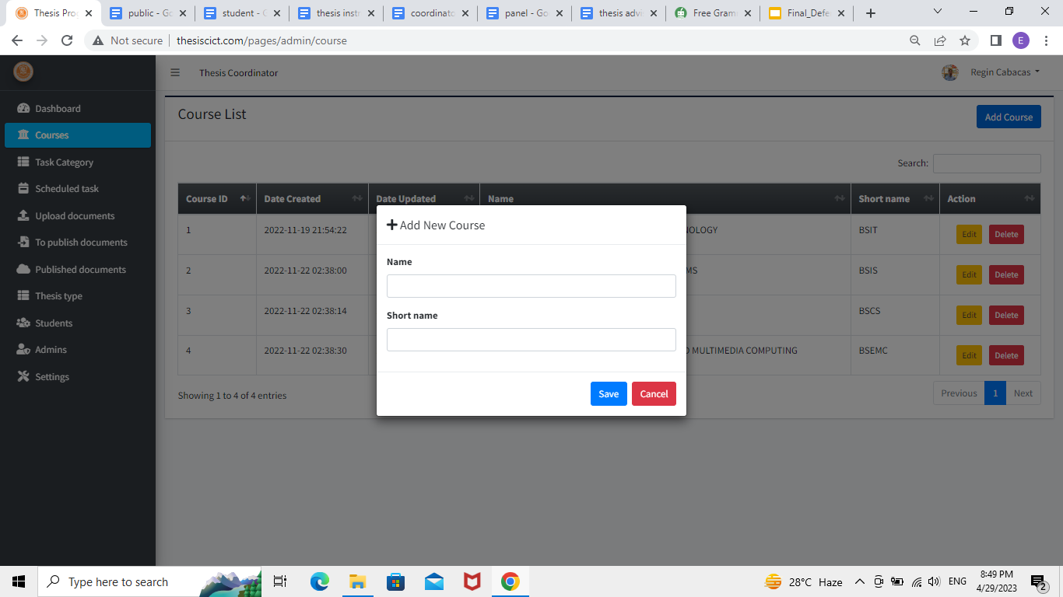**Figure 45.** Add new course option Screen Interface

The "add new course" option allows the thesis coordinator to add a new course by entering its name and abbreviation.

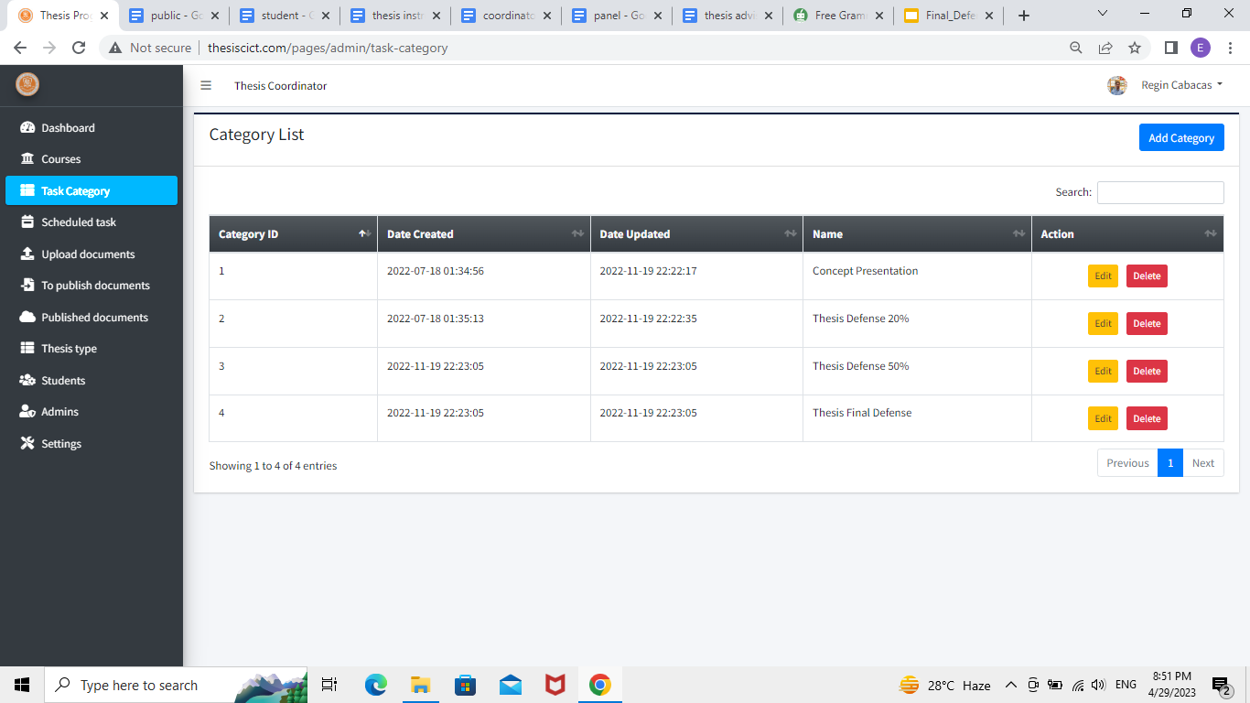**Figure 46.** Task Category tab Screen Interface

The "task category" option allows the thesis coordinator to add, delete or edit a specific task in the system.

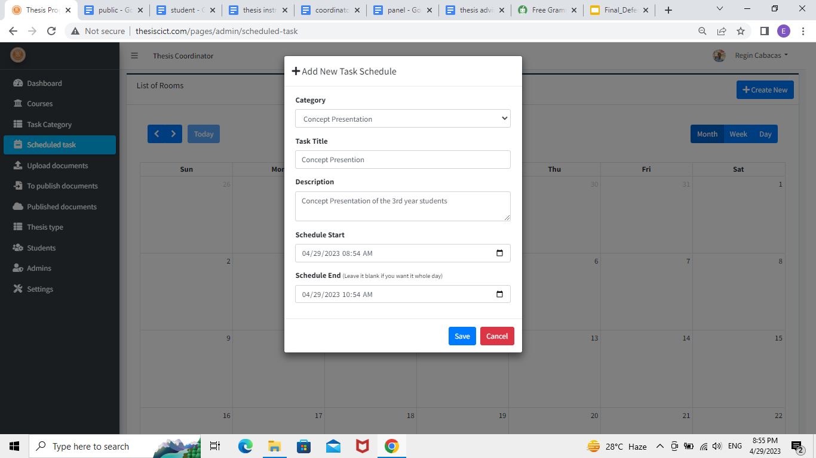**Figure 47.** Scheduled Task tab Screen Interface

The "scheduled task" allows the thesis coordinator to create schedules for thesis defenses and presentations.

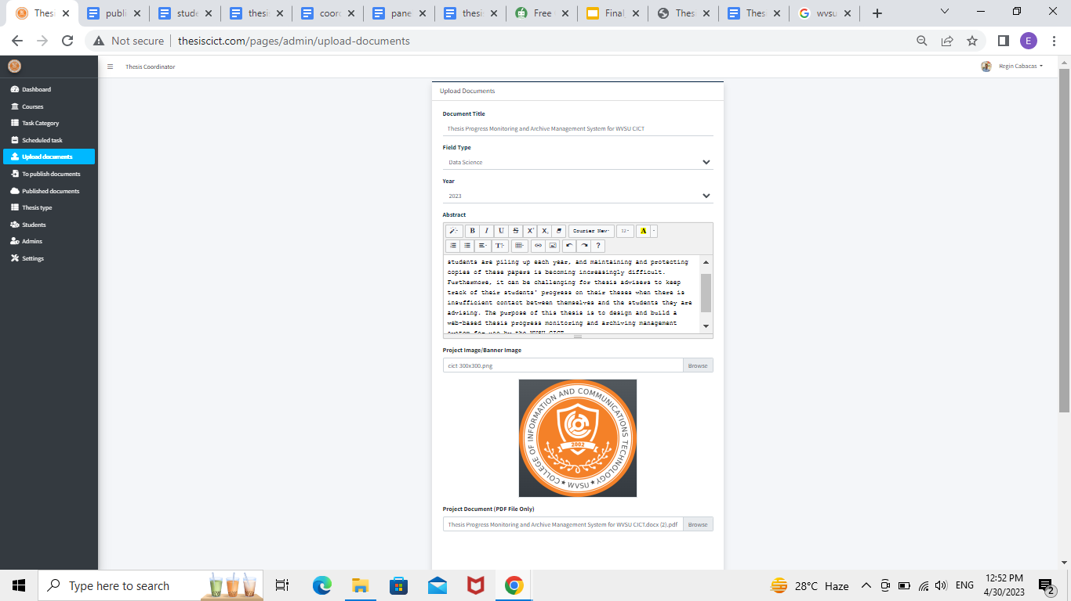

**Figure 48.** Upload documents tab Screen Interface

The "upload documents" option allows the thesis coordinator to upload past documents to be displayed in archives.

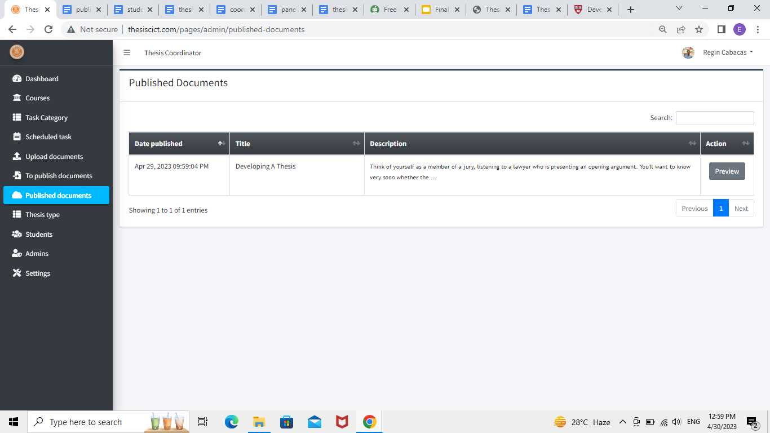**Figure 49.** Published documents tab Screen Interface

The "published documents" option shows the list of uploaded theses with the corresponding date.

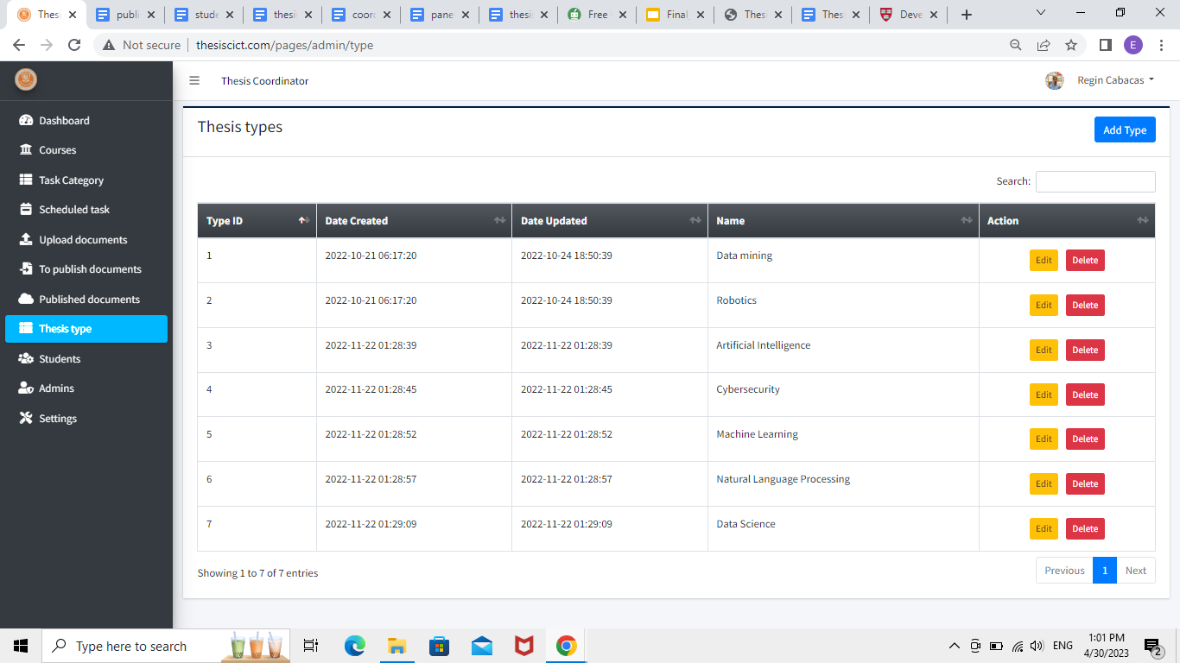**Figure 50.** Thesis type tab Screen Interface

The "thesis type" option allows the thesis coordinator to add, edit, or delete a thesis field type for classification.

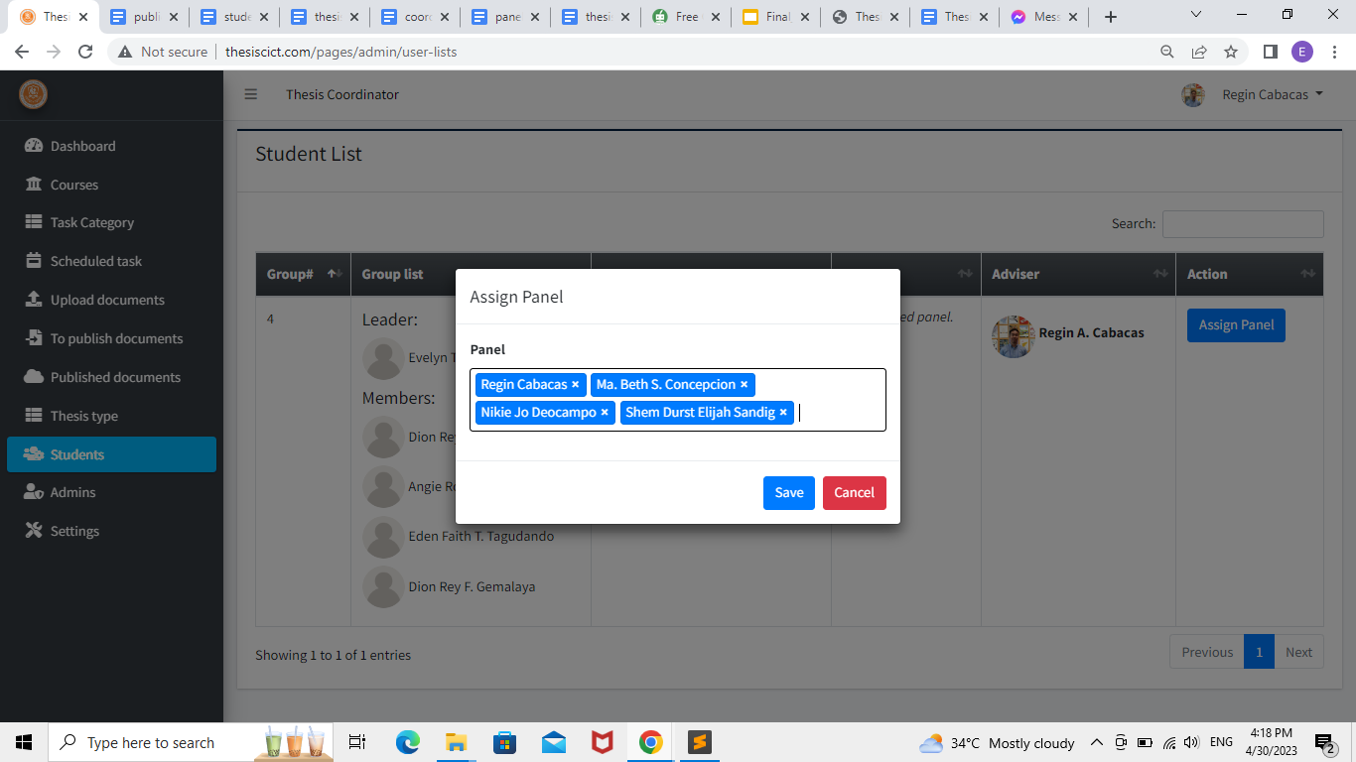

**Figure 51.** Students tab Screen Interface

The "Students" option allows the thesis coordinator to see the list of groupings of the students, their thesis instructor, and their thesis adviser. The user can also assign panels for the presentation of the group.

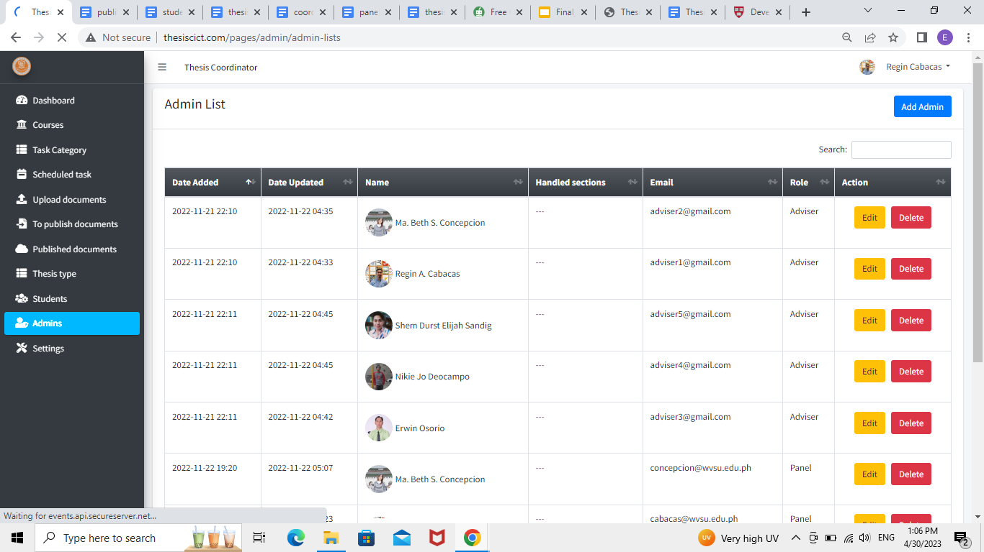

**Figure 52.** Admin tab Screen Interface

The "admin" option allows the thesis coordinator to add, edit, or delete admins from the system.

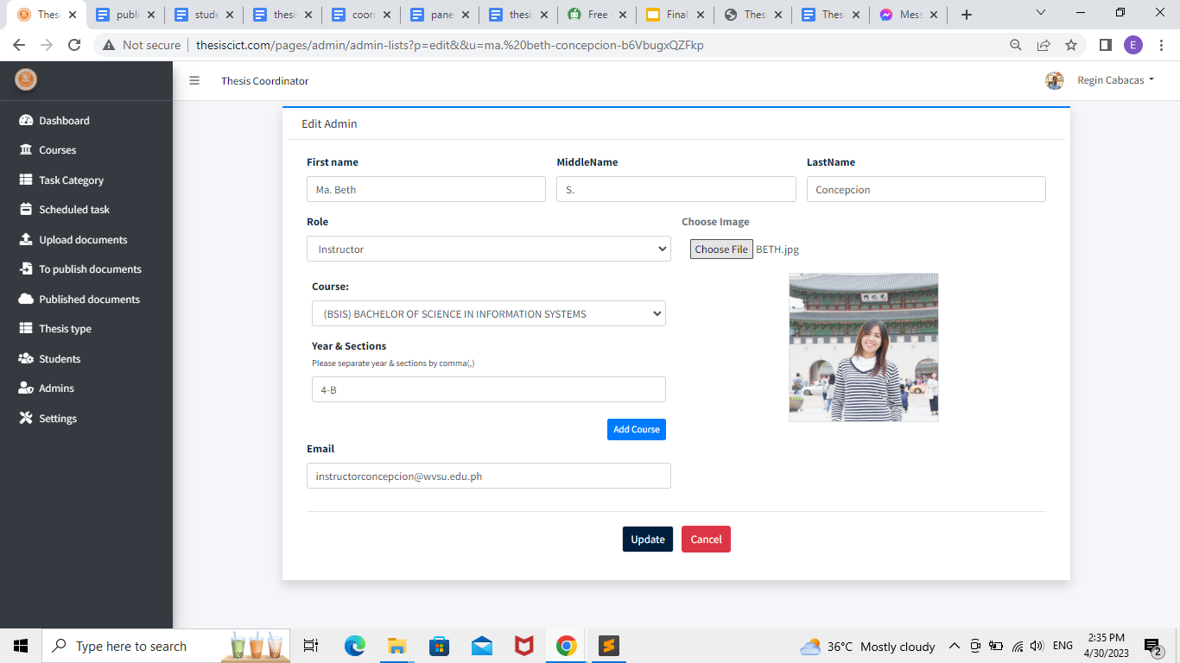**Figure 53.** Assigning of Section Screen Interface

The thesis coordinator is also responsible for assigning the course and section that the thesis instructor will handle; this will be done using the "Admins" option.

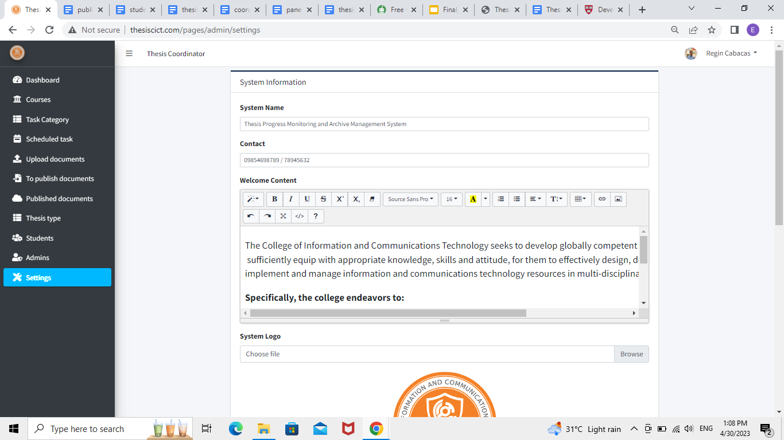

**Figure 54.** Settings tab Screen Interface

The "settings" option allows the thesis coordinator to edit the information displayed on the homepage of the system.

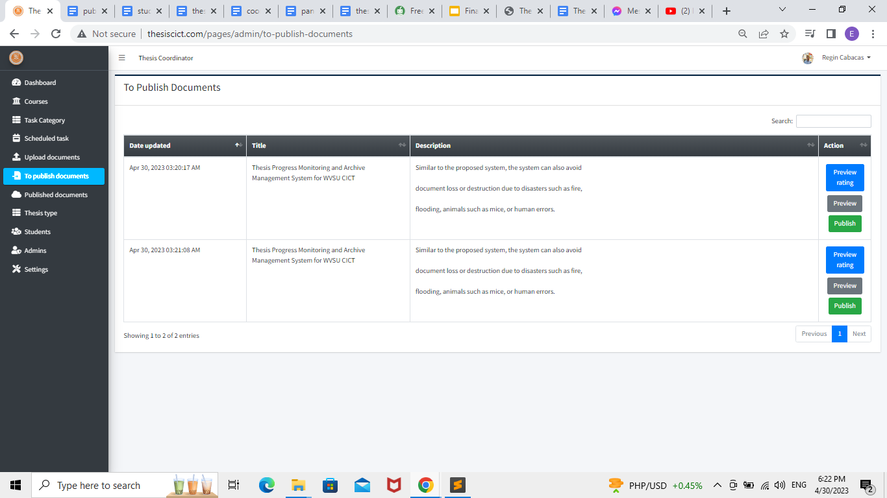

**Figure 55.** To Publish Documents tab Screen Interface

The "To Publish Documents" option allows the thesis coordinator to publish approved thesis documents. They can also preview the ratings made by the panel and the documents made by the group.

## Results Interpretation and Analysis

The system evaluation was carried out with the help of two CICT teachers and a group of CICT students. The researchers included a letter, and the data was collected using an ISO 25010 evaluation form and the attached system.

**Table 1**

ISO 25010 - Functional Stability

|  |  |  |  |  |
| --- | --- | --- | --- | --- |
| Indicators | | Teacher’s Mean | Student’s Mean | Overall Mean |
|  | |  |  |  |
| Completeness | The system covers all the specified tasks and user objectives. | 3.5 | 4.8 | 4.15 |
| Correctness | The system provides the correct results with the needed degree of precision. | 4.5 | 4.6 | 4.55 |
| Appropriateness | The system facilitates the accomplishment of specified tasks and objectives. | 4.5 | 4.6 | 4.55 |

***Functional Stability.*** Based on the findings presented in Table 1, it can be deduced that the system possesses an overall functional stability mean value of 4.41. "Very Good" for completeness, with a mean score of 4.15; "Very Good" for correctness, with a mean score of 4.55; and "Very Good" for appropriateness, with a mean score of 4.55. The findings suggest that the system is able to provide functionalities that are in line with the inferred requirements.

**Table 2**

ISO 25020 - Performance Efficiency

|  |  |  |  |  |
| --- | --- | --- | --- | --- |
| Indicators | | Teacher’s Mean | Student’s Mean | Overall Mean |
| Time Behaviour | The system’s response and processing times and throughput rates when performing its functions, meet requirements. | 5 | 4.4 | 4.7 |
| Resource Utilization | The system’s amount and types of resources used when performing its functions, meet requirements. | 5 | 4.8 | 4.9 |
| Capacity | The system’s maximum limits of parameters meet requirements. | 4.5 | 4.4 | 4.45 |

***Performance Efficiency.*** The aforementioned findings have been compiled to yield an overall performance efficiency mean of 4.68. Time behavior of 4.7, resource usage of 4.9, and capacity mean of 4.45 are all considered l performance efficiency mean of 4.68. Time behavior of 4.7, resource usage of 4.9, and capacity mean of 4.45 are all considered "good." This indicates that the program has achieved the desired level of performance in relation to the resources consumed.

**Table 3**

Compatibility

|  |  |  |  |  |
| --- | --- | --- | --- | --- |
| Indicators | | Teacher’s Mean | Student’s Mean | Overall Mean |
| Co-existence | The system can perform its required functions efficiently while sharing a common environment and resources with other products, without detrimental impact on any other product. | 5 | 4 | 4.5 |
| Interoperability | The system can exchange information and use the information that has been exchanged. | 4.5 | 4.6 | 4.55 |

***Compatibility.*** According to the findings, which are presented in Table 3, the compatibility of the system has been rated as "very good" based on its overall mean score of 4.53. The coexistence was rated as "very good" with a mean score of 4.5, while the interoperability was rated as "very good" with a mean score of 4.55. This indicates that the good, system, or component can share data with other goods, systems, or components and/or carry out its required functions while utilizing the same hardware or software environment as the other goods, systems, or components.

**Table 4**

Usability

|  |  |  |  |  |
| --- | --- | --- | --- | --- |
| Indicators | | Teacher’s Mean | Student’s Mean | Overall Mean |
| Appropriateness Recognizability | The system allows users to recognize if it is appropriate for their needs. | 5 | 4.6 | 4.8 |
| Learnability | The system can be used by specified users to achieve specific goals of learning to use the application with effectiveness, efficiency, freedom from risk and satisfaction in a specified context of use. | 5 | 5 | 5 |
| Operability | The system has attributes that make it easy to operate and control. | 4 | 4.4 | 4.2 |
| User Error Protection | The system protects users against making errors. | 4 | 4.4 | 4.2 |
| User Interaction Aesthetics | The system’s user interface enables pleasing and satisfying interaction for the user. | 5 | 5.6 | 5.3 |
| Accessibility | The system can be used by people with the widest range of characteristics and capabilities to achieve a specified goal in a specified context of use. | 5 | 4.4 | 4.7 |

***Usability.*** According to the data presented in Table 4, the usability of the system is rated as "very good," with an overall mean score of 4.7. "Very Good" appropriateness and recognizability with a mean score of 4.8, "Very Good" learnability with a mean score of 5, "Very Good" operability with a mean score of 4.2, "Very Good" user error protection with a mean score of 4.2, "Very Good" user interface aesthetics with a mean score of 5.3, and "Good" accessibility with a mean score of 4.7. This indicates that the system was able to accomplish a predetermined goal in an effective, efficient, and satisfactory manner.

**Table 5**

Reliability

|  |  |  |  |  |
| --- | --- | --- | --- | --- |
| Indicators | | Teacher Mean | Student Mean | Overall Mean |
| Maturity | The system meets the needs for reliability under normal operation. | 4 | 4.6 | 4.3 |
| Availability | The system is operational and accessible when required for use. | 4.5 | 4.6 | 4.55 |
| Fault Tolerance | The system operates as intended despite the presence of hardware or software faults. | 4 | 4.2 | 4.1 |
| Recoverability | The system can recover the data directly affected and re-establish the desired state. | 4.5 | 4.4 | 4.45 |

***Reliability.*** According to the findings presented in Table 4, the reliability of the system has been rated as "very good" based on its overall mean value of 4.35. "Very Good" recoverability with a mean of 4.45, "Very Good" fault tolerance with a mean of 4.1, and "Very Good" maturity with a mean of 4.3. This indicates that it meets the reliability indicators and consistently maintains a high level of performance.

**Table 6**

ISO - Security

|  |  |  |  |  |
| --- | --- | --- | --- | --- |
| Indicators | | Teacher Mean | Student  Mean | Overall Mean |
| Confidentiality | The system ensures that data are accessible only to those authorized to have access. | 5 | 4.4 | 4.7 |
| Integrity | The system prevents unauthorized access to, or modification of, computer programs or data. | 5 | 4.4 | 4.7 |
| Non-repudiation | The system can be proven to have taken place, so that the events or actions cannot be repudiated later. | 5 | 4.4 | 4.7 |

***Security.*** Table 8's overall mean security value is 4.7, which is considered to be in the "very good" category. "Very Good" confidentiality with a mean score of 4.7, "Very Good" integrity with a mean score of 4.7, "Very Good" non-repudiation with a mean score of 4.7, and "Very Good" integrity with a mean score of 4.7, respectively. This generally indicates that the application is capable of safeguarding information and data from security vulnerabilities.

**Table 7**

ISO - Maintainability

|  |  |  |  |  |
| --- | --- | --- | --- | --- |
| Indicators | | Teacher Mean | Student Mean | Overall Mean |
| Modularity | The application is composed of discrete components such that a change to one component has minimal impact on other components. | 4.5 | 4.4 | 4.45 |
| Reusability | An asset can be used in more than one system, or in building other assets. | 5 | 4.6 | 4.8 |
| Analyzability | The application can be effectively and efficiently modified without introducing defects or degrading existing product quality. | 4.5 | 4.4 | 4.45 |
| Testability | Test criteria can be established for an application, product or component and tests can be performed to determine whether those criteria have been met. | 5 | 4 | 4.5 |

***Maintainability.*** Based on the results that were displayed in table 10, it was determined that the system's maintainability is "very good." The system's overall mean value was 4.55. The modularity was rated as "Very Good" with a mean score of 4.45; the reusability was rated as "Very Good" with a mean score of 4.8; the analyzability was rated as "Very Good" with a mean score of 4.45; and the testability was rated as "Very Good" with a mean score of 4.5. This means the system has reached a level of effectiveness and efficiency where improvements, corrections, or adaptations can be made to the product or system to meet new requirements or an altered context.

System Evaluation Results

**Table 8**

Summary of ISO 25010

|  |  |  |
| --- | --- | --- |
| ISO 25010 | Overall Mean | Interpretation |
| Functional  Stability | 4.42 | Very Good |
| Performance Efficiency | 4.68 | Very Good |
| Compatibility | 4.53 | Very Good |
| Usability | 4.7 | Very Good |
| Reliability | 4.35 | Very Good |
| Security | 4.7 | Very Good |
| Maintainability | 4.55 | Very Good |

Legend: Scales of Mean Description

5 - 4.1 Very Good

4 - 3.1 Good

3 - 2.1 Fair

1.1 Poor Very Poor

The system is evaluated in accordance with the ISO/IEC 25010 standard, which lays the groundwork for evaluating product quality. In the quality model, the quality attributes that will be used to evaluate the properties of a software product are specified. Efficiency is unquestionably defined as the degree to which a system satisfies the explicit and implicit needs of its multiple stakeholders and, as a result, adds value. The quality model, which divides product quality into characteristics and sub-characteristics, takes into account the needs of these stakeholders (functionality, performance efficiency, compatibility, usability, reliability, security, and maintainability). The range of ratings for each criterion is "very good" to "good" to "fair" to "poor" to "very poor."

CHAPTER 5 SUMMARY, CONCLUSIONS, AND RECOMMENDATIONS

Summary of the Proposed Study Design and Implementation

Using the Thesis Progress Monitoring and Archive Management System, students were able to create accounts, select and send invitations to their thesis advisers, and upload documents. Instructors of theses might allocate students to groups and choose a leader. After the defense, the committee can evaluate the presentation and each student and provide a summary of thesis recommendations. The thesis coordinator is able to organize thesis defenses, assign committees, and upload finished research. Using a bar graph, the counting sort method presented the number of studies in each research field.

The Thesis Progress Monitoring and Archive Management System was implemented utilizing the Apache License 2.0-licensed MySQL Server and Apache HTTP Server. The system's principal programming language is PHP, the most recent stable version of the programming language. In addition, JavaScript, CSS, and HTML were utilized on the front end, while PHP was used on the back end. Using XAMPP, the system under development was tested.

## Conclusions

After going through the process of being implemented and tested, the results of the proposed system have shown that it was successful in meeting its objectives, which are as follows:

1. The system was able to enroll and organize students into groups, create schedules for presentations, allow for the submission of documents, and give final approval of ideas.
2. The program includes a list of potential thesis advisers for selection, as well as invitation acceptance or rejection and notification of advisers.
3. Both the finalization of progress presentations and the editing of thesis manuscripts were able to be monitored by the system.
4. The system could be used as a repository for CICT students' past and upcoming theses and research, and it could also classify documents according to the research areas that they were focusing on.
5. According to the results of the survey, the overall performance of the system was evaluated based on the ISO 25010 Standard, and it was found to have a score of 4.56, which is indicative of "Very Good." The needs and requirements of the end users were successfully accommodated by the system.

## Recommendations

The following suggestions are made in light of the findings and observations:

1. To automatically categorize the final thesis documents according to their various research domains;
2. Add a recommendation checklist to the students, thesis advisers, panels, and coordinators interface;
3. To install the system across the university's several colleges;
4. Add grammatical experts and specialists to the system.
5. UI design improvements.

|  |
| --- |
| References |

Addis, & Fassil. (2019, January). *ELECTRONIC DOCUMENT MANAGEMENT SYSTEM FOR St. MARY’S UNIVERSITY*. St. Mary’s University Institutional Repository. http://repository.smuc.edu.et/handle/123456789/5296

Alano, B. J. A., Pesimo, J. A., Quirequire, L. V., & Yalung, D. M. (2018). *THESIS MANAGEMENT SYSTEM*.

Dhanavandan, S., & Tamizhchelvan, M. (2013). Development of Shodhganga repository for electronic theses and dissertations in Tamil Nadu: A study. *International Research: Journal of Library and Information Science*, *3*(4).

Del Rosario, E., Del Rosario, J., Nieva, M., Tan, T., & Tangkeko, M. (2016, March). CollaborateIT: A CCS IT thesis portal with electronic document management system. In *Proc. of the DLSU Research Congress* (Vol. 4).

Goodhue, D. L., Klein, B. D., Salvatore, T., & Thompson, R. L. (2006). Task-technology fit. *Human-Computer Interaction and Management Information Systems: Foundations*, 184-204.

Hameed, K. W., Ahmed, S. A., & Mohammed, A. A. (2015). Web Based Archiving System. *i-Manager's Journal on Information Technology*, *4*(3), 14.

Kao, C. H., & Liu, S. T. (2013). Development of a document management system for private cloud environment. *Procedia-Social and Behavioral Sciences*, *73*, 424-429.

Locke, E. A., & Latham, G. P. (2002). Building a practically useful theory of goal setting and task motivation. American Psychologist, 57(9), 705-717.

Lunenburg, F. C. (2011). Goal-setting theory of motivation. *International journal of management, business, and administration*, *15*(1), 1-6.

Mkpojiogu, E. O., Akusu, G. E., Hussain, A., & Hashim, W. (2020). Implementation of a web-based data archival management system. *International Journal of Advanced Science and Technology*, *29*(6), 307-319.

Omotayo, F. O., & Haliru, A. (2020). Perception of task-technology fit of digital library among undergraduates in selected universities in Nigeria. *The Journal of Academic Librarianship*, *46*(1), 102097.

Putra, J. (2020, June). Data Management System for Thesis Monitoring at STMIK IBBI Using B-Model. In *2020 3rd International Conference on Mechanical, Electronics, Computer, and Industrial Technology (MECnIT)* (pp. 365-369). IEEE.

Ramadhan, M. R., Nugroho, L. E., Sulistyo, S., Grafika, J., Yogyakarta, N., & Sumur, B. (2017). Perancangan Sistem Informasi Monitoring Skripsi. In *Proceedings of Conference on Information Technology and Electrical Engineering* (pp. 290-295).

Wang, H. (2011, May). The design and implementation of online management system for undergraduates' thesis (project). In *2011 International Conference on E-Business and E-Government (ICEE)* (pp. 1-4). IEEE.

Xie, L. (2006). *Evaluation of the electronic document and record management program in a Canadian municipality* (Doctoral dissertation, University of British Columbia).

# Appendices

## Appendix A

## Letter to the Adviser

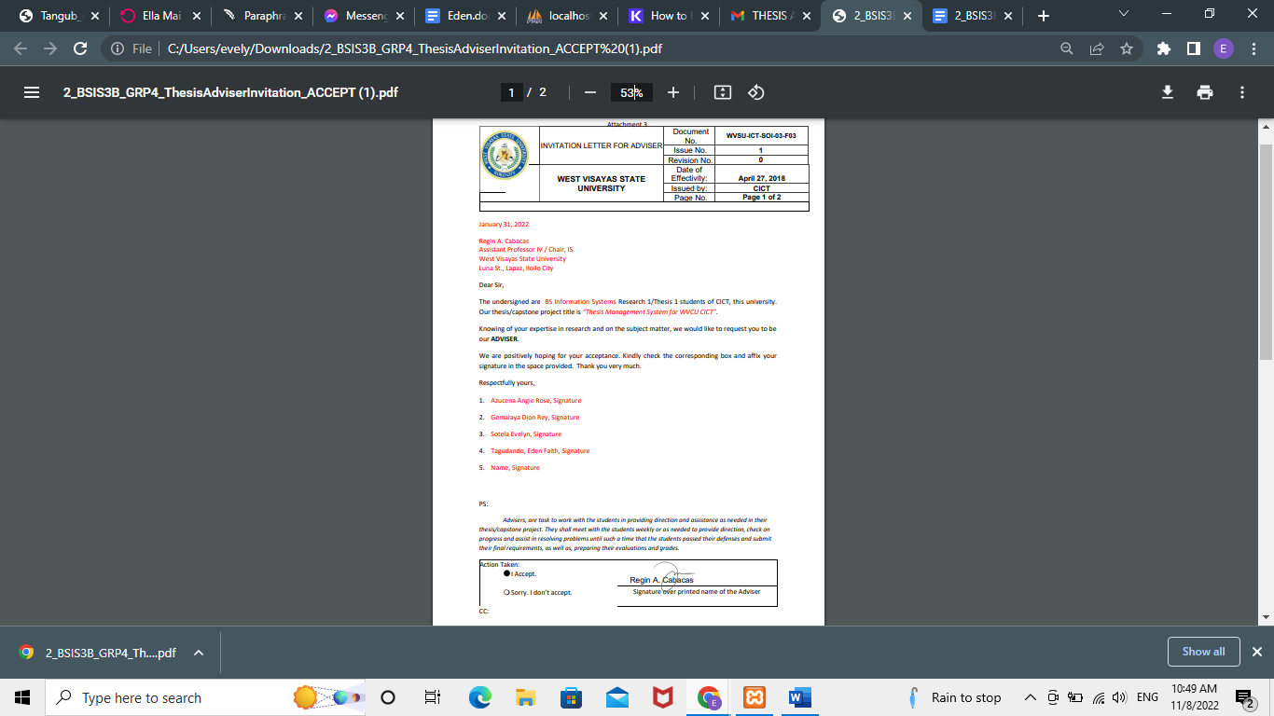

## Appendix B.

## Letter of Request to the Editor

## Appendix C.

## Gantt Chart

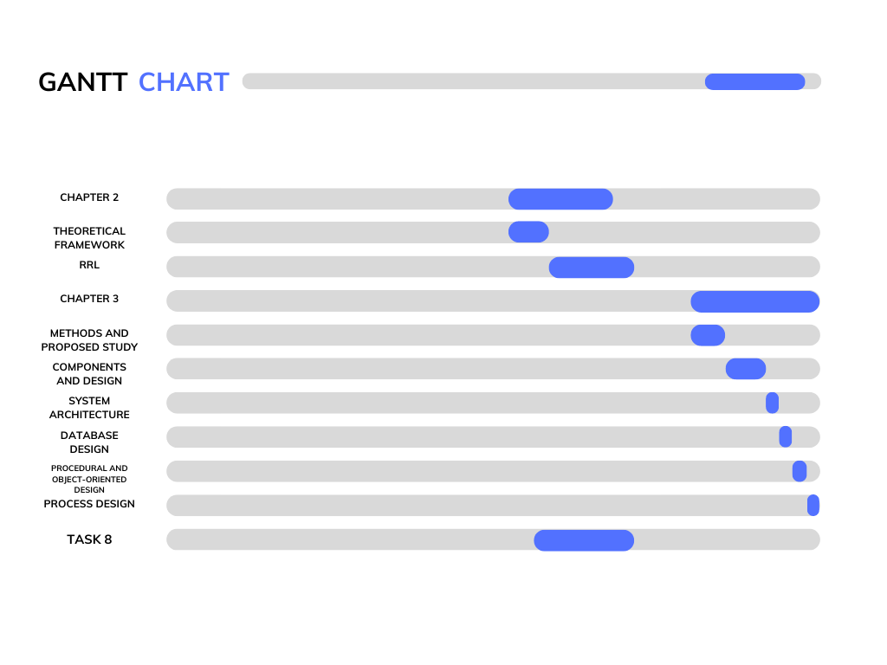

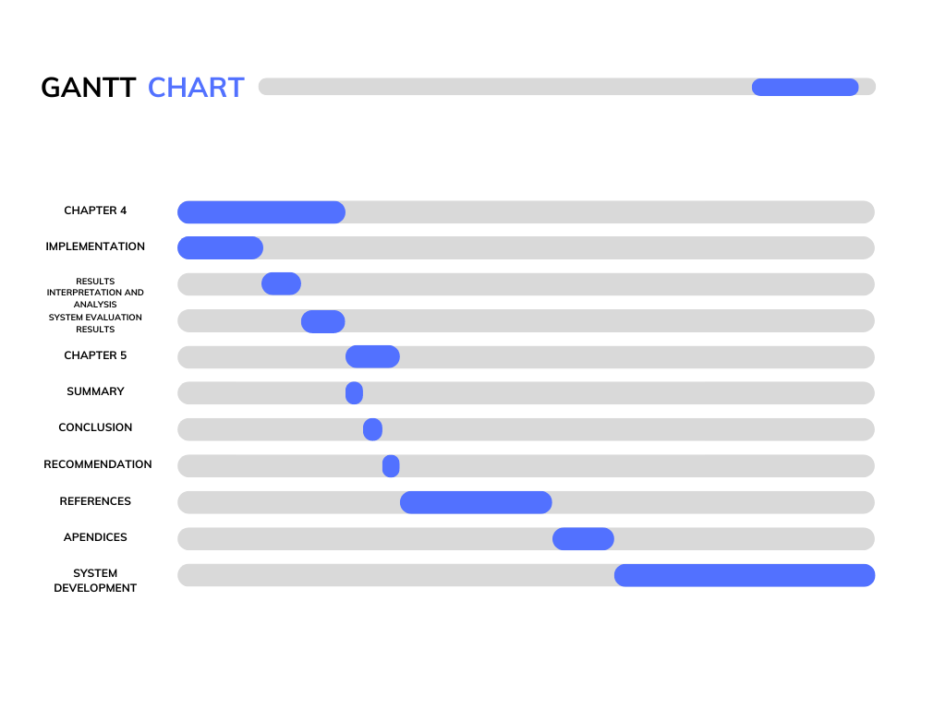

## Appendix D.

## Entity Relationship Diagram

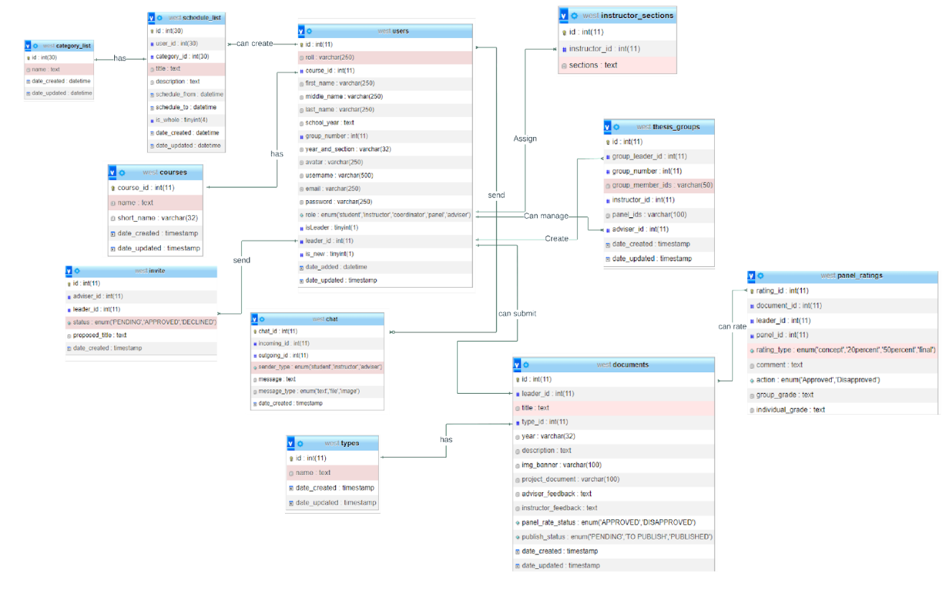

## Appendix E.

## Data Dictionary

|  |  |  |  |  |
| --- | --- | --- | --- | --- |
| **category_list** | | | | |
| Column | Type | Null | Default | Extra |
| id | int(30) | No |  | auto_increment |
| name | text | No |  |  |
| date_created | datetime | No | current_timestamp() |  |
| date_updated | datetime | No | current_timestamp() | on update current_timestamp() |

|  |  |  |  |  |
| --- | --- | --- | --- | --- |
| **documents** | | | | |
| **column** | **Type** | **Null** | **Default** | **Extra** |
| **id** | int(11) | No |  | auto_increment |
| leader_id | int(11) | No |  |  |
| title | text | No |  |  |
| type_id | int(11) | No |  |  |
| year | varchar(100) | No |  |  |
| description | text | No |  |  |
| img_banner | varchar(100) | No |  |  |
| project_document | varchar(100) | No |  |  |
| feedbacks | text | No |  |  |
| project_status | enum('returned to student', 'to check by aviser', 'to check by instructor',' to check by panel', 'to publish') | No |  |  |
| publish_status | enum('PENDING', 'TO PUBLISH', 'PUBLISHED') | No |  |  |
| date_created | timestamp | No | current_timestamp() |  |
| date_updated | timestamp | No | current_timestamp() | on update current_timestamp() |

|  |  |  |  |  |
| --- | --- | --- | --- | --- |
| **invite** | | | | |
| **column** | **Type** | **Null** | **Default** | **Extra** |
| id | int(11) | No |  | auto_increment |
| adviser_id | int(11) | No |  |  |
| leadedr_id | int(11) | No |  |  |
| status | enum('PENDING', 'APPROVED', 'DECLINED') | No |  |  |
| proposed_title | text | No |  |  |
| date_created | timestamp | No | current_timestamp() |  |

|  |  |  |  |  |
| --- | --- | --- | --- | --- |
| **schedule_list** | | | | |
| **column** | **Type** | **Null** | **Default** | **Extra** |
| id | int(30) | No |  | auto_increment |
| user_id | int(30) | No |  |  |
| category_id | int(30) | No |  |  |
| title | text | No |  |  |
| description | text | No |  |  |
| scedule_from | datetime | No |  |  |
| schedule_to | datetime | Yes | NULL |  |
| is_whole | tinyint(4) | No | 0 |  |
| date_created | datetime | No | current_timestamp() |  |
| date_updated | datetime | No | current_timestamp() | on update current_timestamp() |

|  |  |  |  |  |
| --- | --- | --- | --- | --- |
| **system_config** | | | | |
| **column** | **Type** | **Null** | **Default** | **Extra** |
| id | int(11) | No |  | auto_increment |
| system_name | text | No |  |  |
| home_content | text | No |  |  |
| cover | varchar(250) | No |  |  |
| logo | varchar(250) | No |  |  |
| contact | varchar(100) | No |  |  |
|  |  |  |  |  |

|  |  |  |  |  |
| --- | --- | --- | --- | --- |
| **thesis_groups** | | | | |
| **column** | **Type** | **Null** | **Default** | **Extra** |
| id | int(11) | No |  | auto_increment |
| group_leader | int(11) | No |  |  |
| group_number | int(11) | No |  |  |
| group_member_ids | varchar(50) | No |  |  |
| instructor_id | int(11) | Yes | NULL |  |
| panel_id | int(11) | Yes | NULL |  |
| adviser_id | int(11) | Yes | NULL |  |
| status | tinyint(1) | No |  |  |
| date_created | timestamp | No | current_timestamp() |  |
| date_updated | timestamp | No | current_timestamp() | on update current_timestamp() |

|  |  |  |  |  |
| --- | --- | --- | --- | --- |
| **types** | | | | |
| **column** | **Type** | **Null** | **Default** | **Extra** |
| id | int(11) | No |  | auto_increment |
| name | text | No |  |  |
| date_created | timestamp | No | current-timestamp() |  |
| date_updated | timestamp | No | current-timestamp() | on update current_timestamp() |

|  |  |  |  |  |
| --- | --- | --- | --- | --- |
| **users** | | | | |
| **column** | **Type** | **Null** | **Default** | **Extra** |
| id | int(11) | No |  | auto_increment |
| roll | varchar(250) | Yes | NULL |  |
| first_name | varchar(250) | No |  |  |
| middle_name | varchar(250) | Yes | NULL |  |
| last_name | varchar(250) | No |  |  |
| group_number | int(11) | Yes | NULL |  |
| year_and_section | varchar(32) | Yes | NULL |  |
| avatar | varchar(250) | Yes | NULL |  |
| username | varchar(250) | No |  |  |
| email | varchar(250) | No |  |  |
| password | varchar(250) | Yes | NULL |  |
| role | enum('student', 'coordinator', 'panel', 'adviser') | No |  |  |
| isLeader | tinyint(1) | Yes | NULL |  |
| leader_id | int(11) | Yes | NULL |  |
| is_new | tinyint(1) | No |  |  |
| date_added | datetime | No |  |  |
| date_updated | timestamp | No | current_timestamp() | on update currrent_timestamp() |

## Appendix F.

## Letter of Request to the Thesis Format Editor

## Appendix G.

## Sample Program Codes

## Appendix H.

## Software Quality Evaluation Form/ ISO Questionnaire

Using the scale below evaluate the system by placing a check (**✓**) mark on the appropriate column.

5 - Very Good 4 - Good 3 - Fair 2 - Poor 1 - Very Poor

1. Functional Stability

|  |  |  |  |  |  |  |
| --- | --- | --- | --- | --- | --- | --- |
| Indicators | | 5 | 4 | 3 | 2 | 1 |
| Completeness | The system covers all the specified tasks and user objectives. |  |  |  |  |  |
| Correctness | The system provides the correct results with the needed degree of precision. |  |  |  |  |  |
| Appropriateness | The system facilitates the accomplishment of specified tasks and objectives. |  |  |  |  |  |

1. Performance Efficiency

|  |  |  |  |  |  |  |
| --- | --- | --- | --- | --- | --- | --- |
| Indicators | | 5 | 4 | 3 | 2 | 1 |
| Time Behaviour | The system’s response and processing times and throughput rates when performing its functions, meet requirements. |  |  |  |  |  |
| Resource Utilization | The system’s amount and types of resources used when performing its functions, meet requirements. |  |  |  |  |  |
| Capacity | The system’s maximum limits of parameters meet requirements. |  |  |  |  |  |

1. Compatibility

|  |  |  |  |  |  |  |
| --- | --- | --- | --- | --- | --- | --- |
| Indicators | | 5 | 4 | 3 | 2 | 1 |
| Co-existence | The system can perform its required functions efficiently while sharing a common environment and resources with other products, without detrimental impact on any other product. |  |  |  |  |  |
| Interoperability | The system can exchange information and use the information that has been exchanged. |  |  |  |  |  |

1. Usability

|  |  |  |  |  |  |  |
| --- | --- | --- | --- | --- | --- | --- |
| Indicators | | 5 | 4 | 3 | 2 | 1 |
| Appropriateness Recognizability | The system allows users to recognize if it is appropriate for their needs. |  |  |  |  |  |
| Learnability | The system can be used by specified users to achieve specific goals of learning to use the application with effectiveness, efficiency, freedom from risk and satisfaction in a specified context of use. |  |  |  |  |  |
| Operability | The system has attributes that make it easy to operate and control. |  |  |  |  |  |
| User Error Protection | The system protects users against making errors. |  |  |  |  |  |
| User Interaction Aesthetics | The system’s user interface enables pleasing and satisfying interaction for the user. |  |  |  |  |  |
| Accessibility | The system can be used by people with the widest range of characteristics and capabilities to achieve a specified goal in a specified context of use. |  |  |  |  |  |

1. Reliability

|  |  |  |  |  |  |  |
| --- | --- | --- | --- | --- | --- | --- |
| Indicators | | 5 | 4 | 3 | 2 | 1 |
| Maturity | The system meets the needs for reliability under normal operation. |  |  |  |  |  |
| Availability | The system is operational and accessible when required for use. |  |  |  |  |  |
| Fault Tolerance | The system operates as intended despite the presence of hardware or software faults. |  |  |  |  |  |
| Recoverability | The system can recover the data directly affected and re-establish the desired state. |  |  |  |  |  |

1. Security

|  |  |  |  |  |  |  |
| --- | --- | --- | --- | --- | --- | --- |
| Indicators | | 5 | 4 | 3 | 2 | 1 |
| Confidentiality | The system ensures that data are accessible only to those authorized to have access. |  |  |  |  |  |
| Integrity | The system prevents unauthorized access to, or modification of, computer programs or data. |  |  |  |  |  |
| Non-repudiation | The system can be proven to have taken place, so that the events or actions cannot be repudiated later. |  |  |  |  |  |

1. Maintainability

|  |  |  |  |  |  |  |
| --- | --- | --- | --- | --- | --- | --- |
| Indicators | | 5 | 4 | 3 | 2 | 1 |
| Modularity | The application is composed of discrete components such that a change to one component has minimal impact on other components. |  |  |  |  |  |
| Reusability | An asset can be used in more than one system, or in building other assets. |  |  |  |  |  |
| Analyzability | The application can be effectively and efficiently modified without introducing defects or degrading existing product quality. |  |  |  |  |  |
| Testability | Test criteria can be established for an application, product or component and tests can be performed to determine whether those criteria have been met. |  |  |  |  |  |

## Appendix I.

## Disclaimer

This system project and its corresponding documentation, entitled "Thesis Progress Monitoring and Archive Management System for WVSU CICT," are submitted to the College of Information and Communications Technology, West Visayas State University, in partial fulfillment of the requirements for the degree [Bachelor of Science in Information Systems]. It is the product of our own work, except where indicated in the text.

We give the College of Information and Communications Technology permission to freely use, publish in local or international journals or conferences, reproduce, or distribute paper and electronic copies of this software project and its documentation, in whole or in part, as long as we are credited.

Angie Rose A. Azucena

Dion Rey F. Gemalaya

Evelyn T. Sotela

Eden Faith T. Tagudando

June 2023